Study data: Data Name: Review of baby dresses on different e-commerce sites we collected and prepared the data set in csv format ( **Fin_B_0-500.csv**) , in which we have 2718 Rows and 4 columns

Step 1: Data pre-processing

* For any data analysis project we must have to clean the data to get real insights so i performed all the basic data cleaning process like lowercase conversions, removal of numbers , removal of punctuations, removal of symbols , stop word removal
* For Data cleaning , I used Python 3.6 version in Google Colab because Google Colab is much easier in handling the data and you can also save the notebooks in your google drive.
* For lowercase conversions, removal of numbers , removal of punctuations, removal of symbols , I used Python based Pandas library and for removal of hinglish words, spelling corrections , sentence correction and disjoint of words we used Excel sheet and processed manually.
* **lower case conversion**: Converting all our data to lowercase helps in the process of preprocessing and in later stages in the NLP application, when we’ll do parsing.

**removal of numbers**: we should remove or ignore numbers within the text because numbers are not significant in our problem statement.

**removal of punctuation** :It helps to get rid of unhelpful parts of the data

**removal of stop words** :since stop words occur in abundance, hence providing little to no unique information that can be used for classification or clustering.

The data was exported in this file name ‘**Data.csv’**

After pre processed, the data obtained was having <2553 rows and 2 columns>

Step 2: Sentiment analysis

* For sentiment scores, I imported all the required libraries of Pandas, Matplotlib and NLTK( Natural Language ToolKit) then I created a dataframe using pandas. Then using textblob I created a sentimental score of our data values.
* NLTK

Tokenization (Tokenization is the first step in text analytics. It is the process of breaking down a textual content paragraph into smaller chunks). ,Stopwords, Stemming(Stemming is the process of producing morphological variants of a root/base word), Lemmatization(Stemming is the process of producing morphological variants of a root/base word)

* For plotting of the sentiments I used R programming language first i imported all the required libraries like syuzhet, wordcloud , ggplot2 and tm then i created a dataframe and used NRC lexicon (eight emotions) and created a vector of all emotions with their scores , plots of review sentiments is attached below





Step 3: Text Clustering

* For the purpose of text clustering we used four libraries which is based on R programming language they are basically **cluster, factoextra,dendextend and ggplot2**
* The amount of text data being generated in recent years has exploded exponentially. It's essential for organizations to have a structure in place to mine actionable insights from the text being generated.
* Text clustering is the task of grouping a set of unlabelled texts in such a way that texts in the same cluster are more similar to each other than to those in other clusters.
* Text clustering algorithms process text and determine if natural clusters (groups) exist in the data
* After sentimental analysis we had file name **R.csv** and we imported and created text clustering image shown below :

Step 4 : Word cloud and Frequent terms and aspect mining

* After generating text clustering dendrogram we created word cloud of texts , most frequent terms in datasets and aspect or opinion mining
* For these purposes we used various python libraries such as NLTK , seaborn , pandas , spacy, vendersentiment and textblob.
* We used **Data.csv** file here to generate all the plots and i am attaching as a reference :
* After deploying aspect mining analysis we have a file named as **Frequent, sentiment and aspect.csv**

Word cloud :

Frequent Terms :

negative class review analysis : After successful creating aspect mining analysis , we studied how many aspects are used for negative reviews and here is the result :



Positive class review analysis : After successful creating aspect mining analysis , we studied how many aspects are used for positive reviews and here is the result :



From the above plot we can observe that in most of the reviews people are sharing their thoughts on products that they purchased .

From the above plot we can observe that in most of the reviews people are sharing their thoughts on quality of the product

Word cloud of negative reviews aspects analysis :

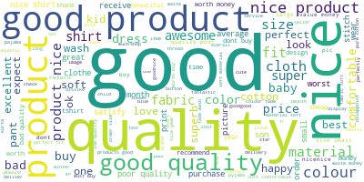

This is for negative class : here we can see the adjectives discussed are bad, worst,poor and criticism shared by customers are fade after washing and quality like aspects .

Positive class review analysis :

Word cloud :

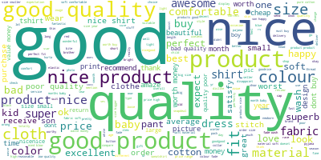

This is for positive reviews. Most of the time adjectives used here are Good , nice, awesome, super,excellent etc and customers have appreciated the quality of the product , fabric,colour ,wash and material.

The last step is to find the optimal number of topics.We need to build many LDA models with different values of the number of topics (k) and pick the one that gives the highest coherence value. Choosing a ‘k’ that marks the end of a rapid growth of topic coherence usually offers meaningful and interpretable topics. Picking an even higher value can sometimes provide more granular sub-topics. If you see the same keywords being repeated in multiple topics, it’s probably a sign that the ‘k’ is too large.

Step 5: Topic Modelling

* After successful completion of aspect mining we have employed topic modeling using LDA (latent dirichlet allocation) techniques , in this we used our final cleaned data set( Data.csv) .
* Topic Modeling is a process to automatically identify topics present in a text object and to derive hidden patterns exhibited by a text corpus. Working of topic modelling is shown below

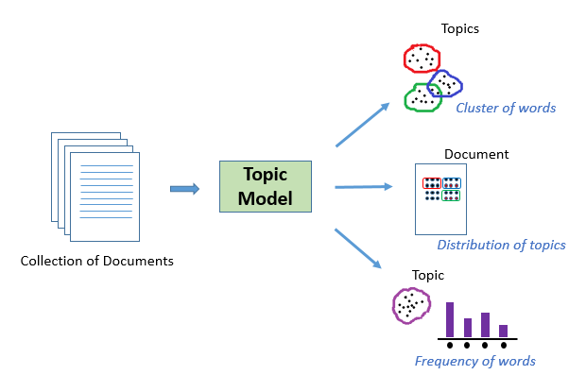

* Before employing topic modelling we used NLTK library to preprocess the dataset again to remove irrelevant words and we generated frequency of words discussed in our data set :



* In our case, instead of text documents, we have thousands of online product reviews for the items listed under the ‘**review**’ category. Our aim here is to extract a certain number of groups of important words from the reviews. These groups of words are basically the topics which would help in ascertaining what the consumers are actually talking about in the reviews

|  |  |  |
| --- | --- | --- |
| Topic | Word | Topic label |
|  | 0.384*"colour" + 0.068*"amazing" + 0.055*"faded" + 0.040*"bit" + 0.034*"long" + 0.031*"yrs" + 0.025*"stuff" + 0.016*"wear" + 0.014*"material" + 0.011*"little” | Color of the kids dress & fading of colour |
|  | 0.154*"superb" + 0.145*"great" + 0.112*"beautiful" + 0.092*"design" + 0.038*"wearing" + 0.033*"fitted" + 0.024*"totally" + 0.023*"dark" + 0.019*"average" + 0.019*"okok" | design & fitting of kid’s dress |
|  | 0.194*"size" + 0.139*"small" + 0.072*"stitching" + 0.054*"quality" + 0.042*"large" + 0.041*"order" + 0.033*"fit" + 0.022*"print" + 0.021*"better" + 0.019*"short" | small size of dress and need for stitches |
|  | 0.262*"quality" + 0.129*"poor" + 0.120*"bad" + 0.061*"dont" + 0.045*"material" + 0.044*"buy" + 0.043*"wash" + 0.027*"worst" + 0.025*"cheap" + 0.016*"low" | poor quality of kid’s dress |
|  | 0.257*"cloth" + 0.072*"quality" + 0.068*"average" + 0.056*"stars" + 0.045*"nicenice" + 0.029*"worst" + 0.028*"torn" + 0.021*"five" + 0.018*"set" + 0.018*"four" | quality of the cloth of kid’s dress |
| 6. | 0.234*"dress" + 0.103*"good" + 0.069*"fitting" + 0.050*"baby" + 0.041*"perfectly" + 0.037*"fits" + 0.035*"image" + 0.030*"boys" + 0.028*"perfect" + 0.023*"material" | good fitting of the baby boy’s dress & good material |
| 7. | 0.278*"super" + 0.069*"quality" + 0.051*"cute" + 0.047*"time" + 0.044*"son" + 0.032*"suit" + 0.026*"stitches" + 0.022*"wow" + 0.017*"looked" + 0.016*"change" | Superb quality product for boys |
| 8 | 0.138*"comfortable" + 0.093*"size" + 0.076*"ordered" + 0.064*"months" + 0.051*"love" + 0.043*"year" + 0.038*"boy" + 0.029*"blue" + 0.028*"old" + 0.026*"colors" | Fitting & durability of boy’s dress |
| 9 | 0.270*"money" + 0.160*"worth" + 0.102*"waste" + 0.074*"value" + 0.041*"buying" + 0.021*"wastage" + 0.019*"worst" + 0.014*"mind" + 0.012*"softness" + 0.010*"like" | wastage of money & not recommended to buy |
| 10 | 0.066*"years" + 0.045*"satisfied" + 0.037*"goodgood" + 0.026*"elastic" + 0.024*"pants" + 0.023*"rate" + 0.021*"cost" + 0.019*"okay" + 0.018*"suitable" + 0.015*"price” | Durability & price of the dress |
| 11 | 0.336*"shirt" + 0.123*"picture" + 0.060*"tshirt" + 0.027*"thank" + 0.026*"look" + 0.019*"price" + 0.019*"true" + 0.014*"costly" + 0.014*"used" + 0.013*"jack" | Pictures of different types of dress |
| 12 | 0.125*"happy" + 0.093*"quality" + 0.052*"pants" + 0.051*"dislike" + 0.045*"star" + 0.045*"shirts" + 0.039*"red" + 0.038*"thanks" + 0.030*"product" + 0.023*"threading" | Happiness with quality & recommend to buy |
| 13 | '0.613*"nice" + 0.111*"products" + 0.026*"much" + 0.020*"loved" + 0.018*"son" + 0.009*"occasion" + 0.009*"niceits" + 0.006*"goodgood" + 0.006*"buysuper" + 0.006*"vgood" | Quality & reviews of the product |
| 14 | 0.506*"good" + 0.173*"product" + 0.159*"quality" + 0.025*"price" + 0.010*"different" + 0.009*"looking" + 0.009*"pic" + 0.009*"material" + 0.006*"clothes" + 0.005*"age" | Satisfaction with quality and recommended to buy |
| 15 | 0.154*"good" + 0.121*"fit" + 0.102*"fabric" + 0.097*"perfect" + 0.082*"excellent" + 0.050*"kids" + 0.034*"expected" + 0.033*"material" + 0.031*"son" + 0.015*"service" | fitting & fibre of the boy’s dress |
| 16 | 0.395*"product" + 0.206*"nice" + 0.064*"buy" + 0.046*"price" + 0.036*"cotton" + 0.017*"seller" + 0.017*"delivery" + 0.015*"must" + 0.013*"time" + 0.012*"delivered" | Fabric & on time delivery of the product |
| 17 | 0.237*"awesome" + 0.102*"baby" + 0.087*"product" + 0.043*"material" + 0.032*"fade" + 0.030*"brother" + 0.019*"feeling" + 0.018*"fit" + 0.016*"fading" + 0.016*"happy" | Material & fading of colour of baby dress |
| 18 | 0.090*"best" + 0.047*"received" + 0.043*"colours" + 0.029*"disappointed" + 0.029*"colour" + 0.028*"cotton" + 0.022*"high" + 0.019*"expectation" + 0.019*"price" + 0.017*"range" | colour and fibre of the product |
| 19 | '0.164*"color" + 0.130*"one" + 0.089*"expected" + 0.044*"clothes" + 0.026*"fantastic" + 0.024*"brand" + 0.021*"nicegood" + 0.019*"really" + 0.017*"goodnice" + 0.015*"photo" | Color & quality of the dress & recommended to buy |
| 20 | 0.145*"soft" + 0.070*"purchase" + 0.056*"material" + 0.044*"pant" + 0.043*"size" + 0.035*"bought" + 0.033*"fabric" + 0.031*"kid" + 0.024*"month" + 0.022*"return" | Material & fitting of kid’s dress |

* Visualization of Topics : We used pyldavis packages in association with gensim to generate visualization of topics and here is the screenshot of visualization for topics , we can see these kinds of vis for any topic

For Topic 1:

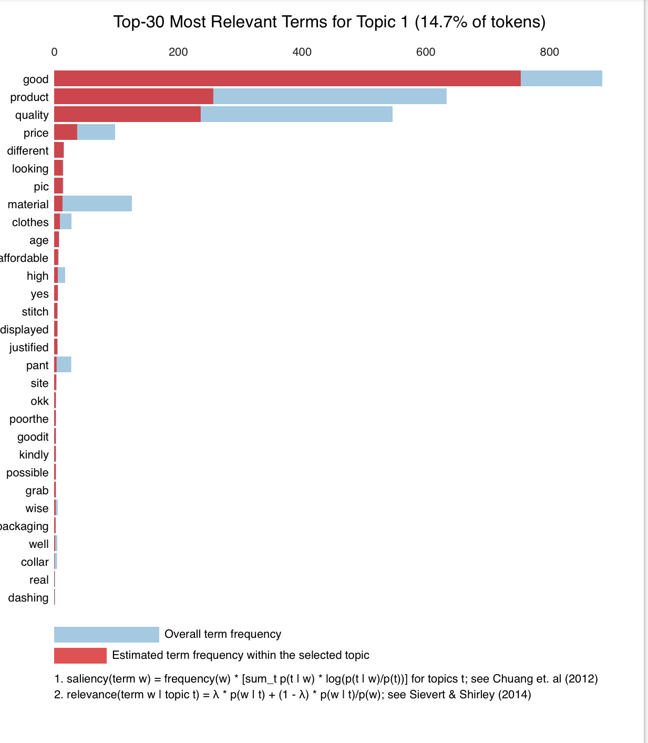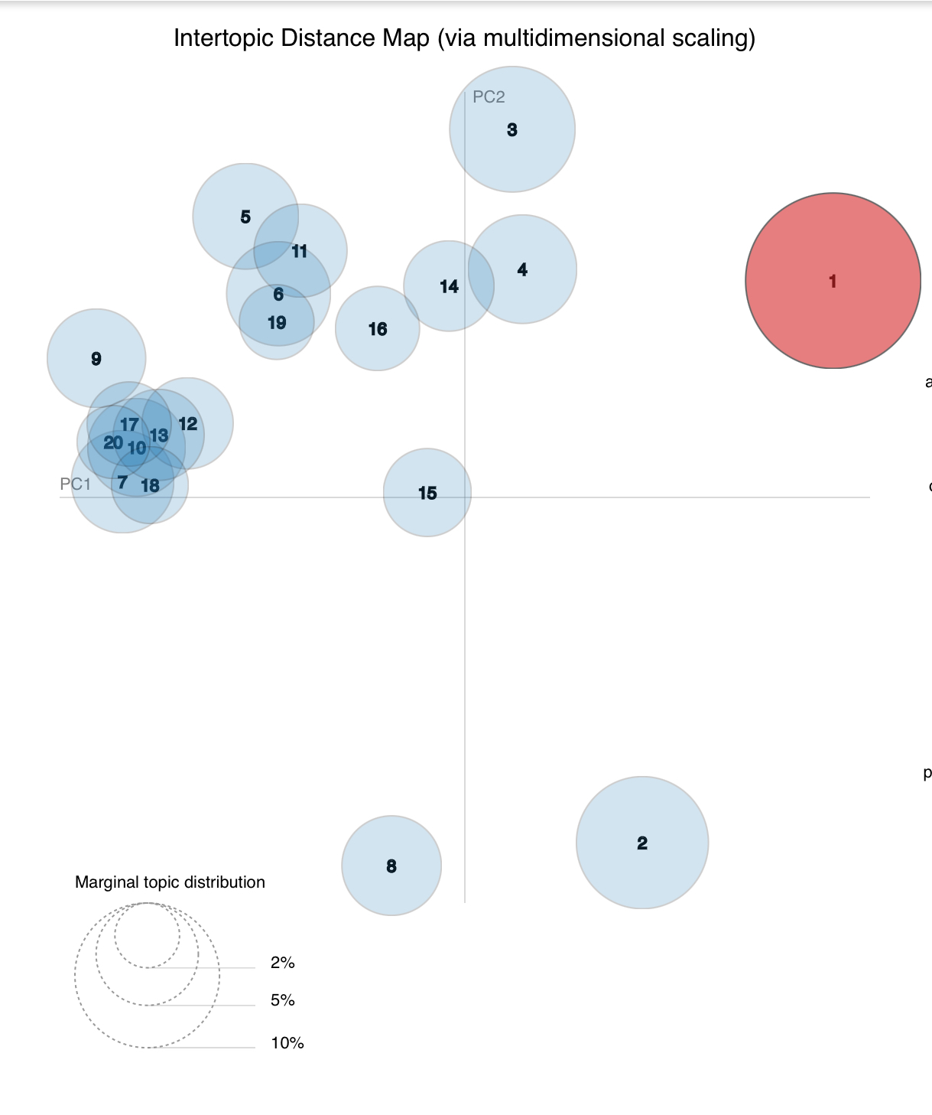

For Topic 2:

‘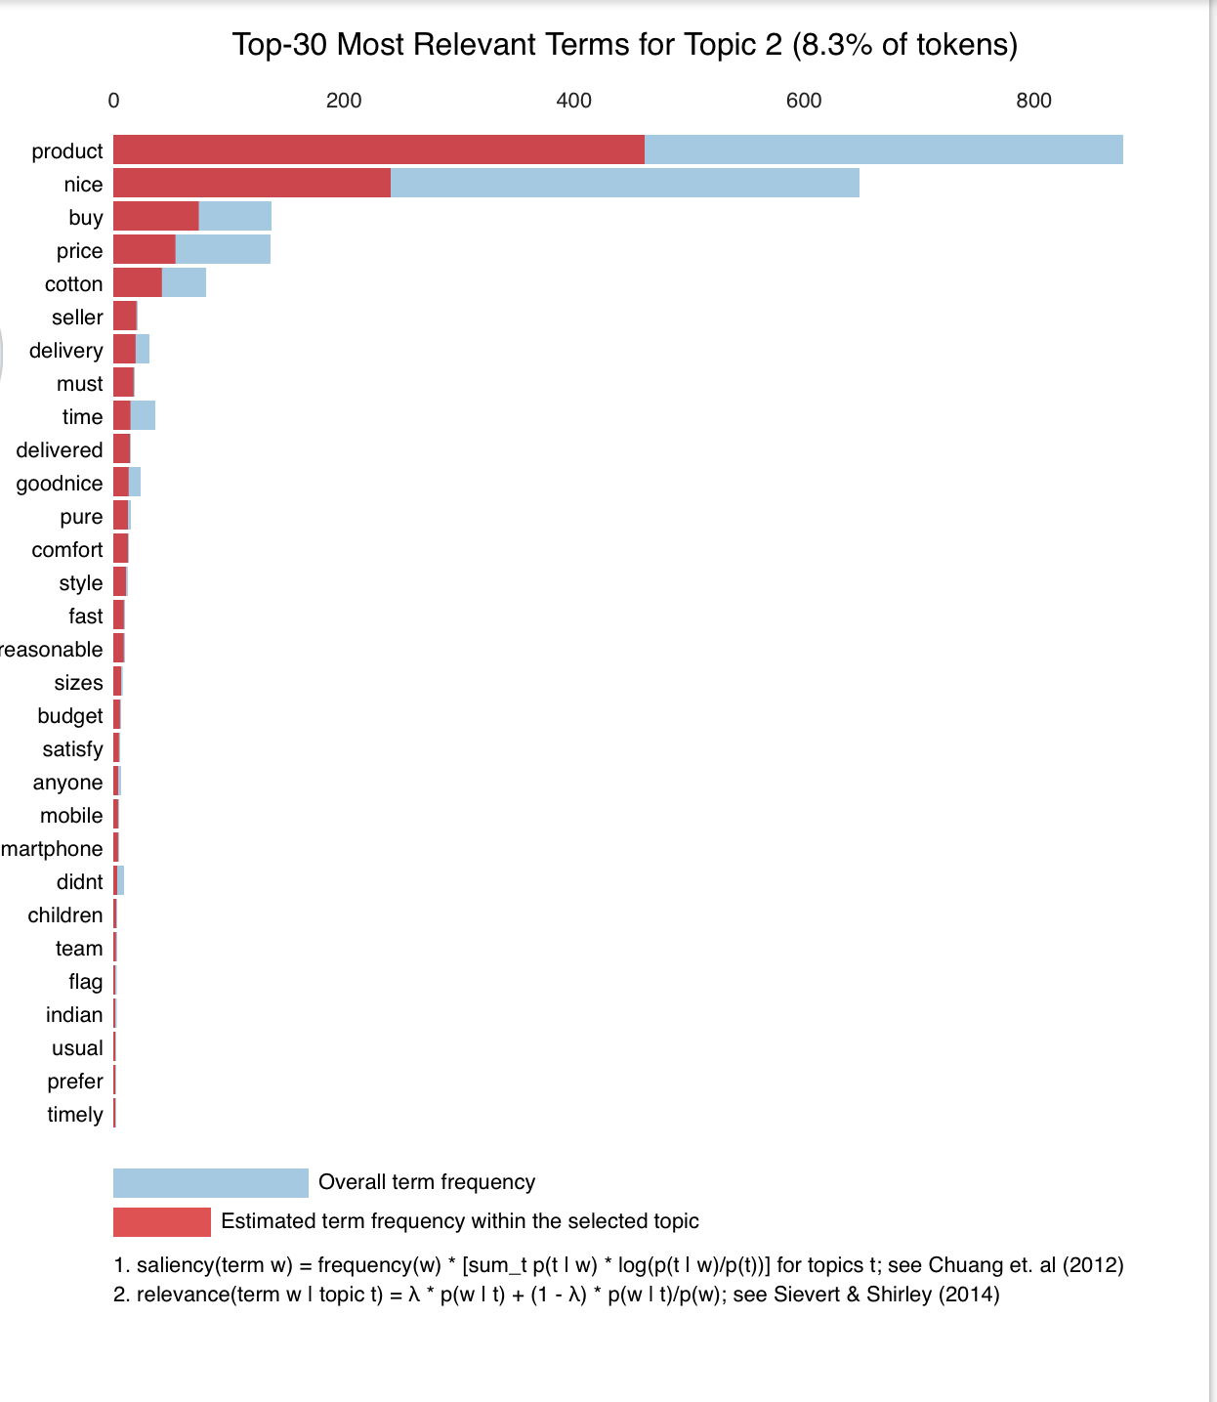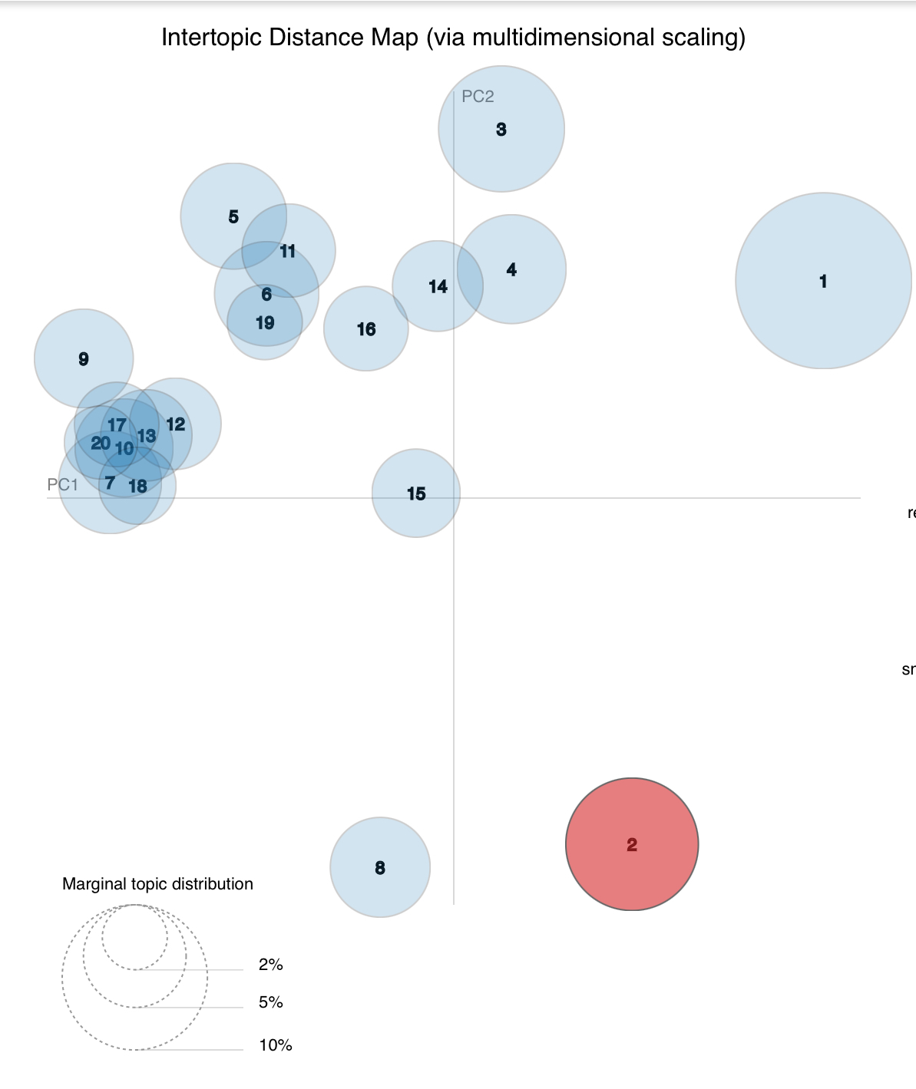

For Topic 3 :

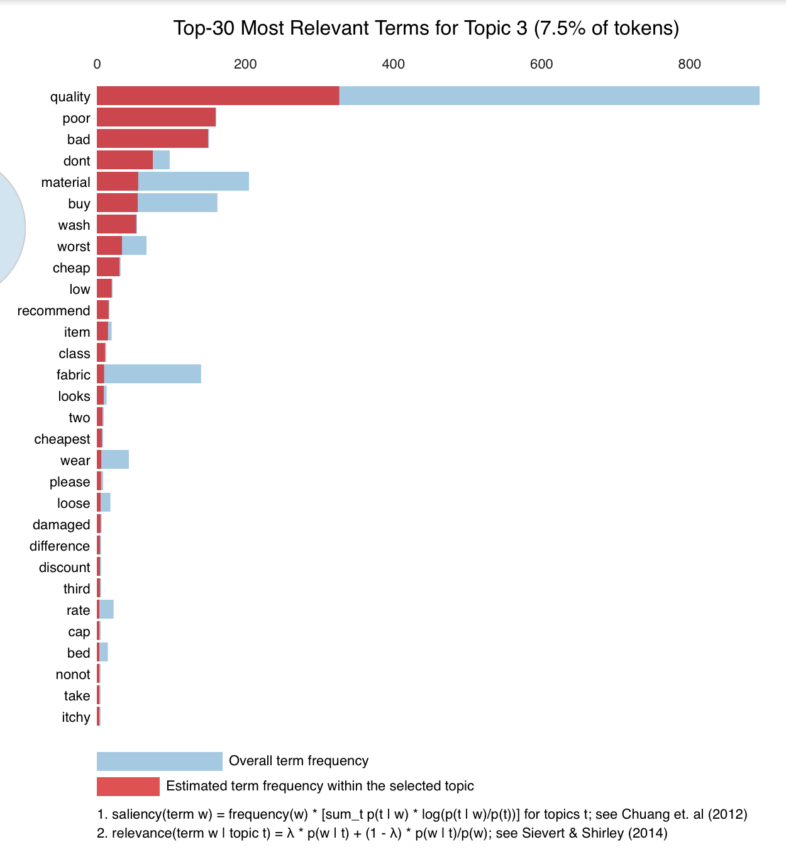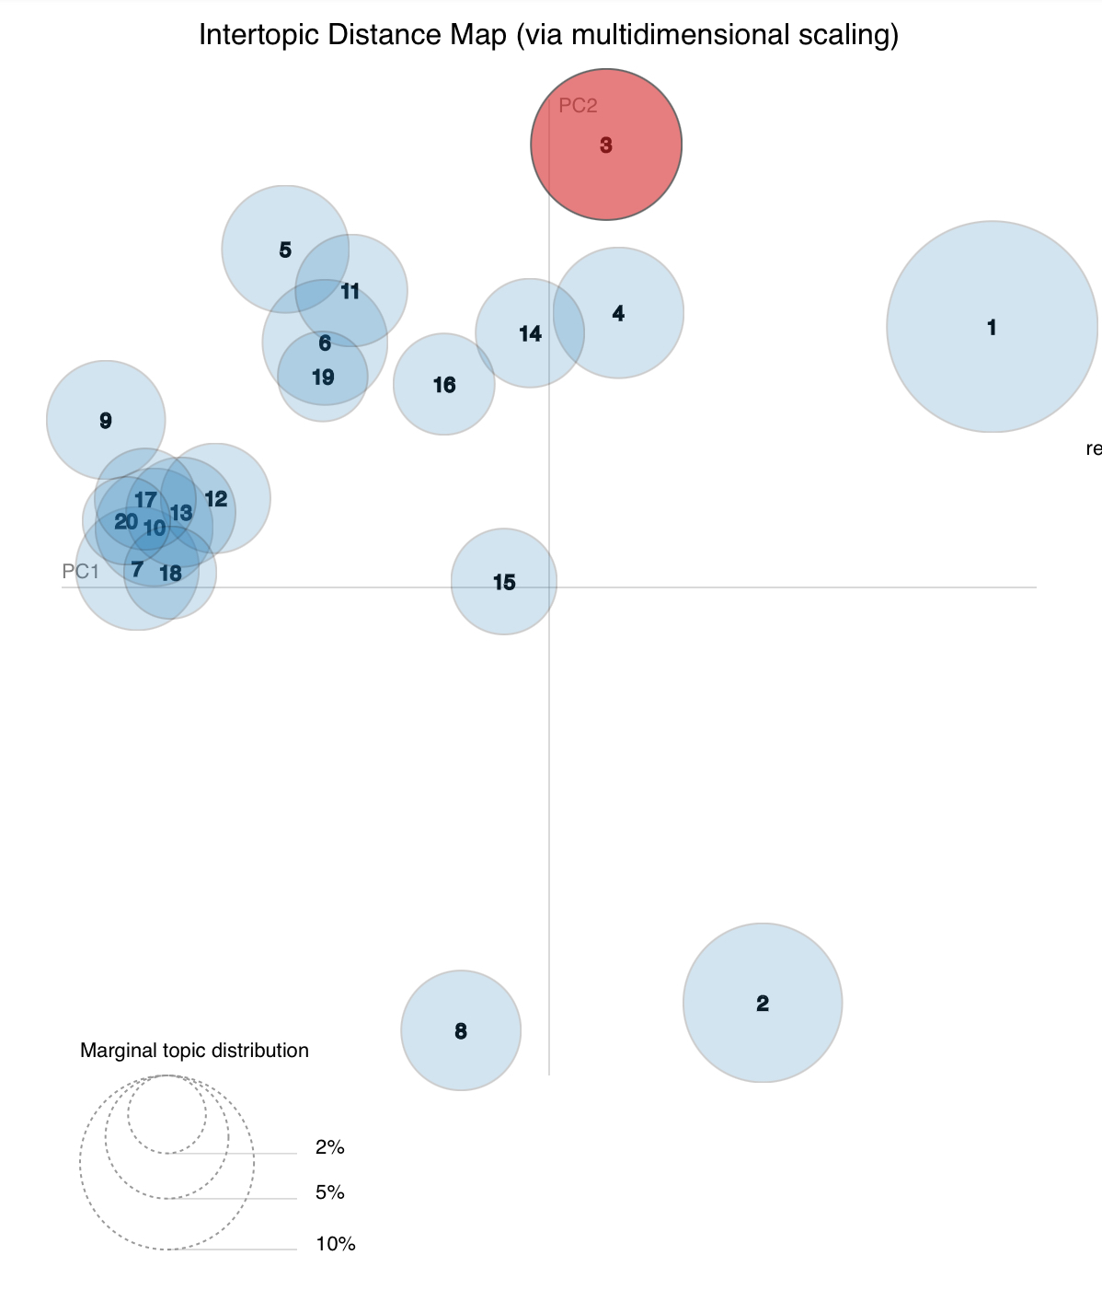

ForTopic 4 :

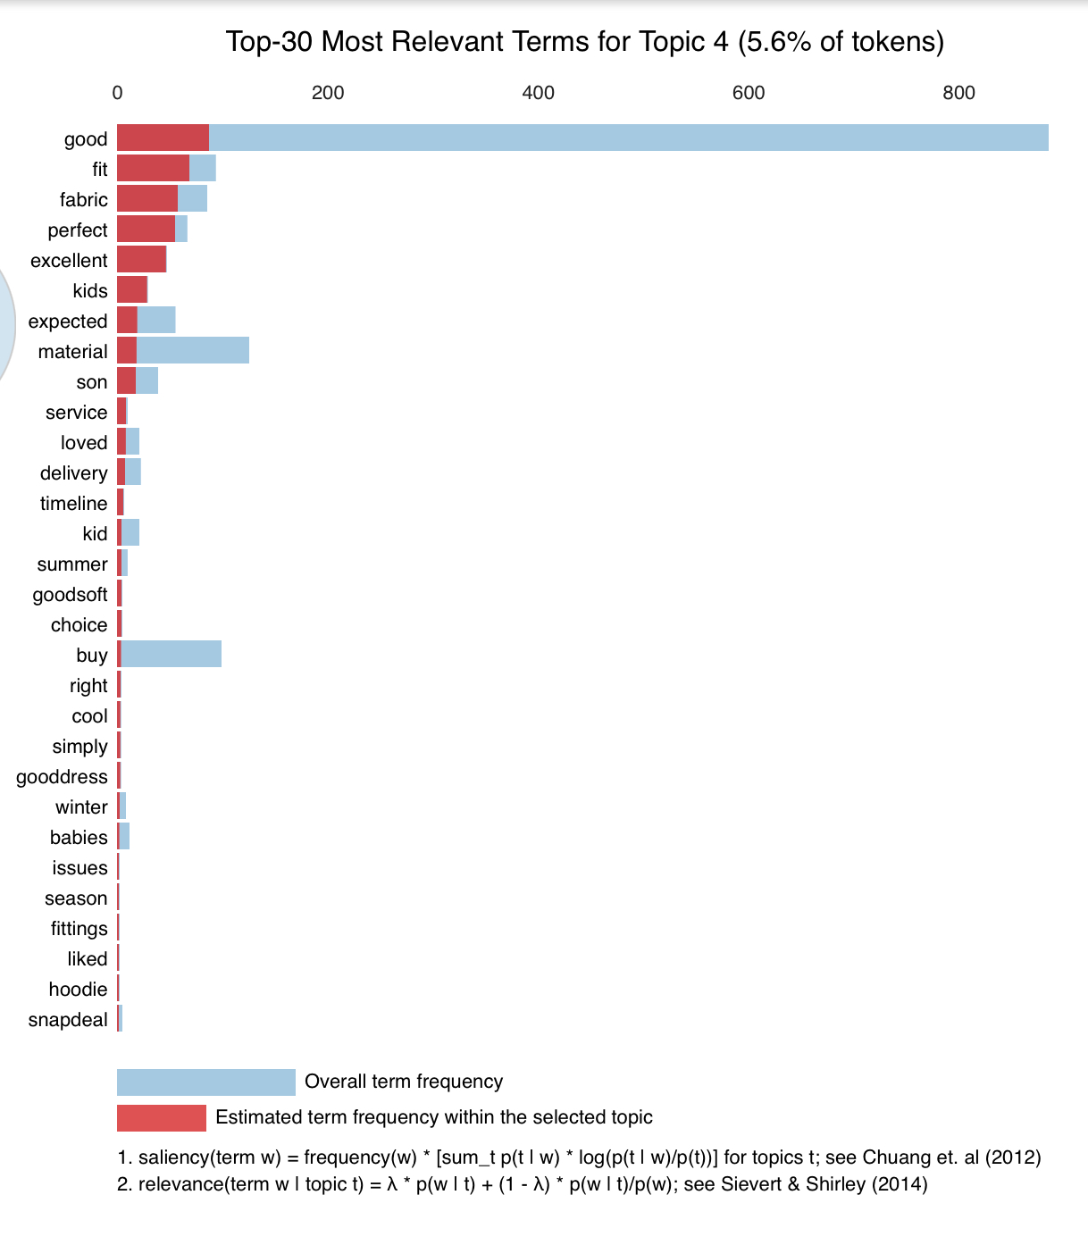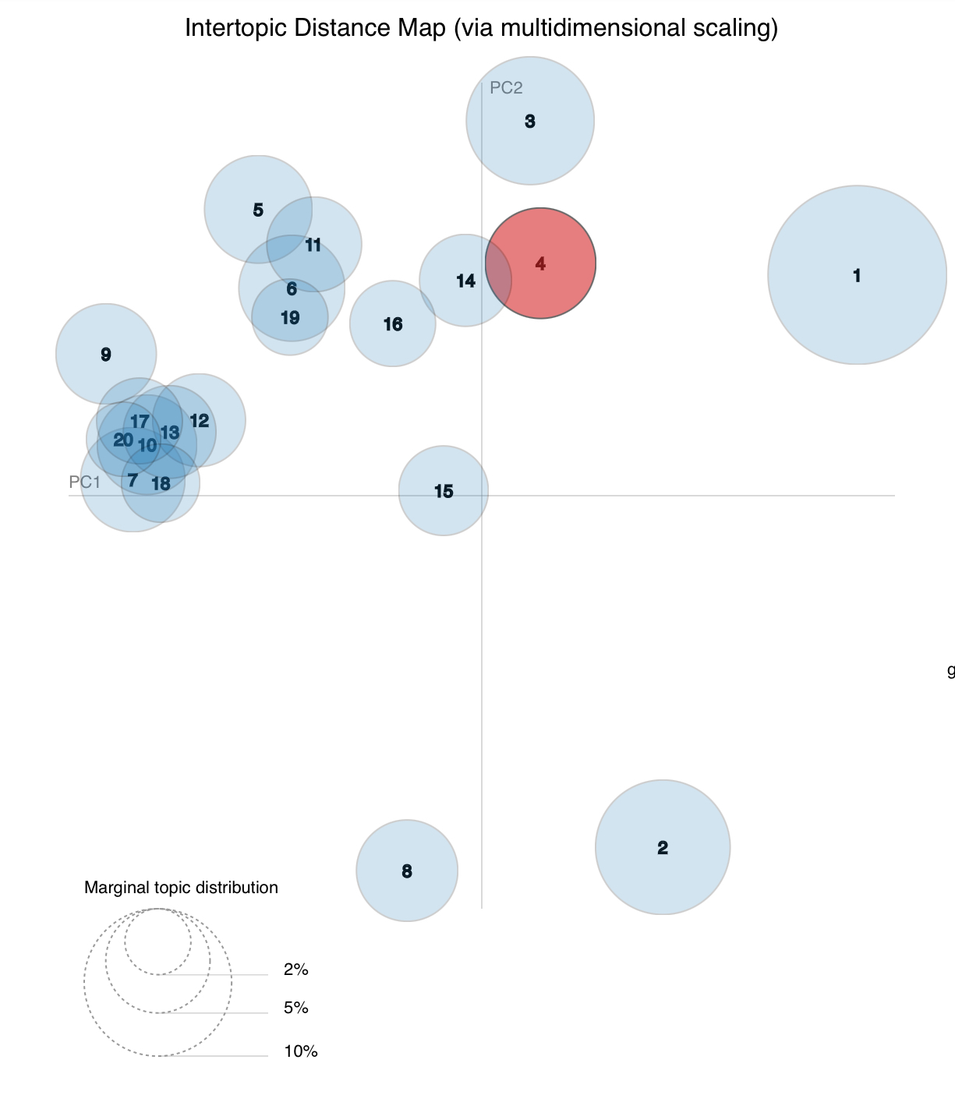

Topic 5 :

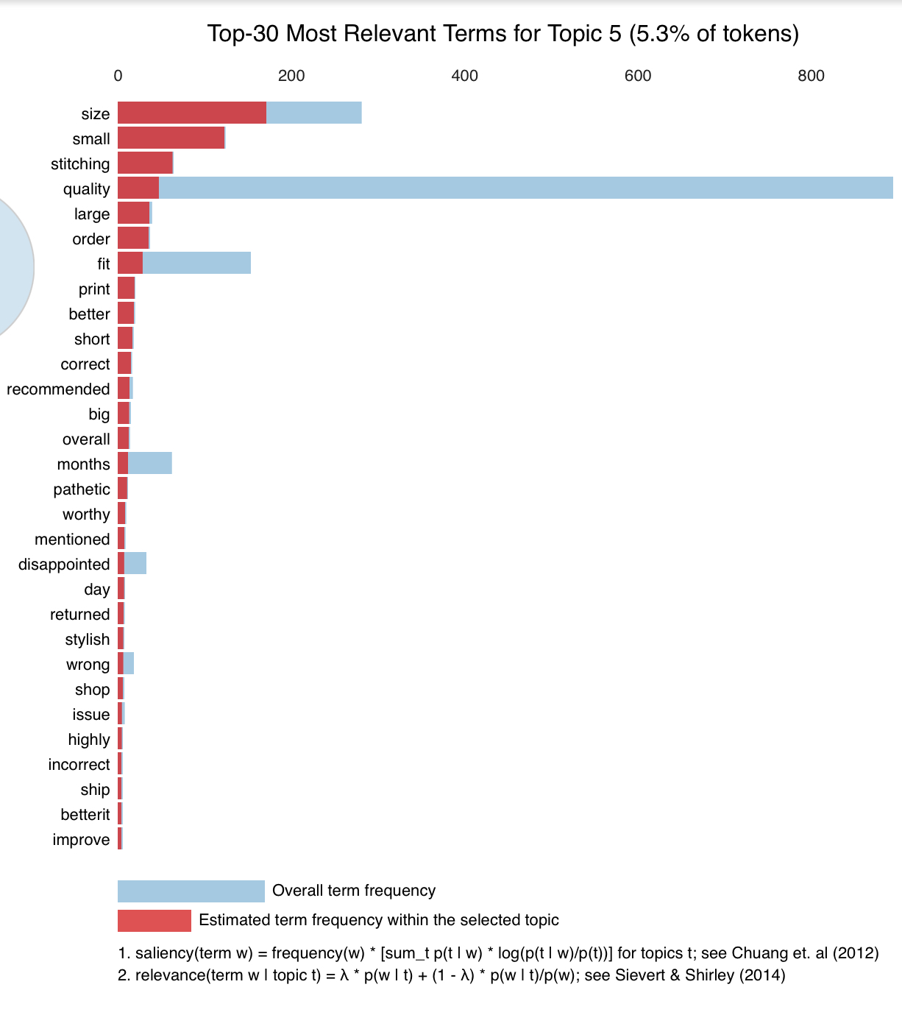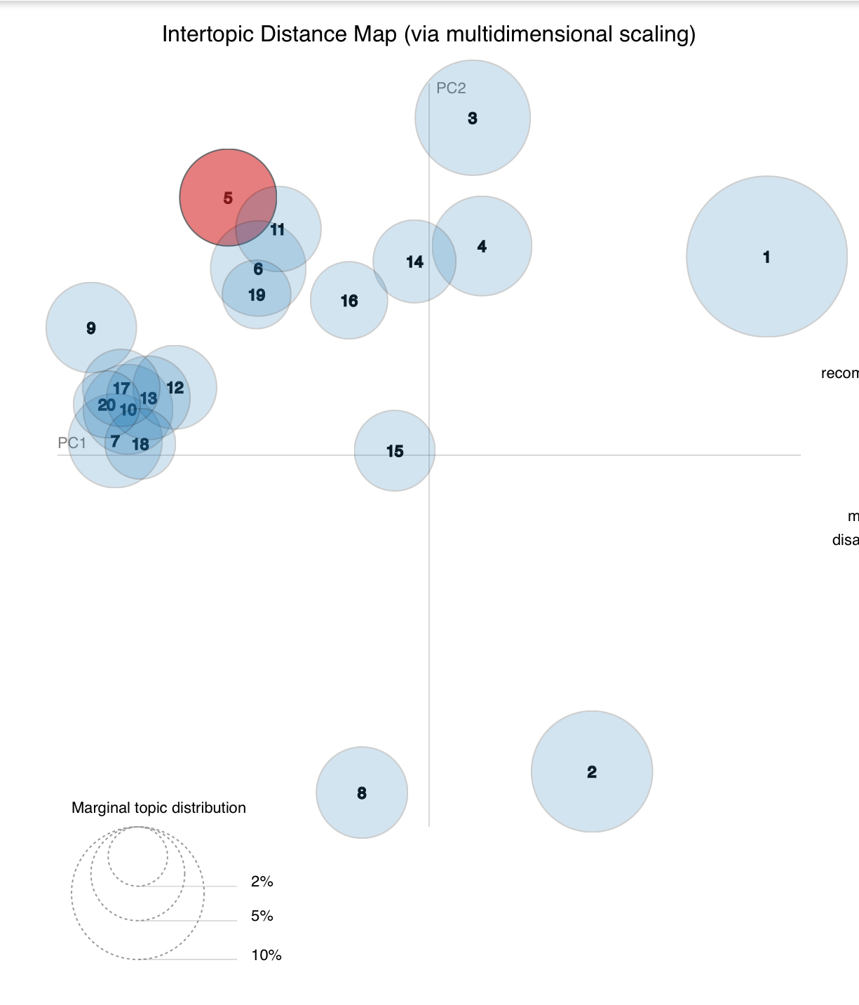

For Topic 6 :

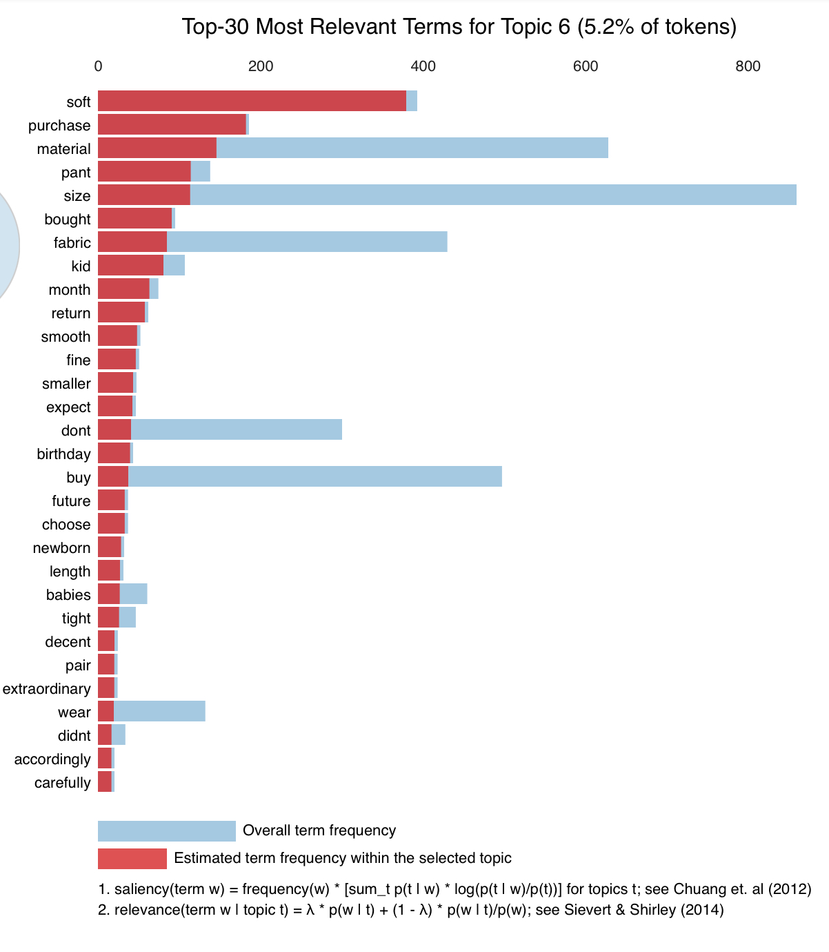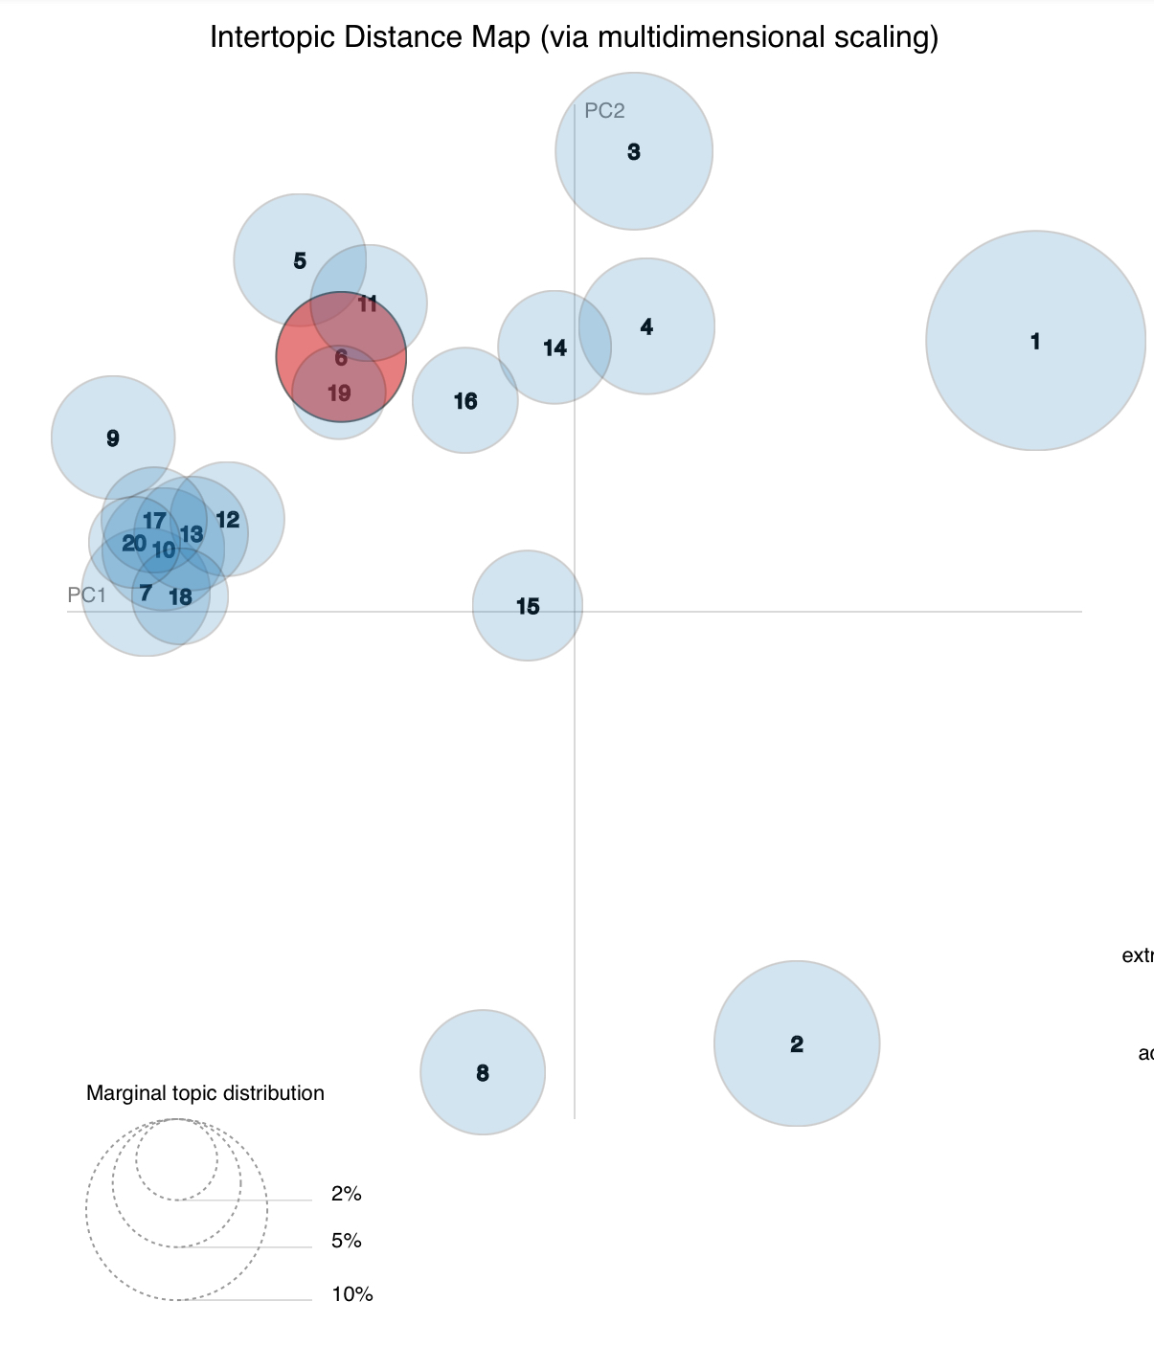

For Topic 7 :

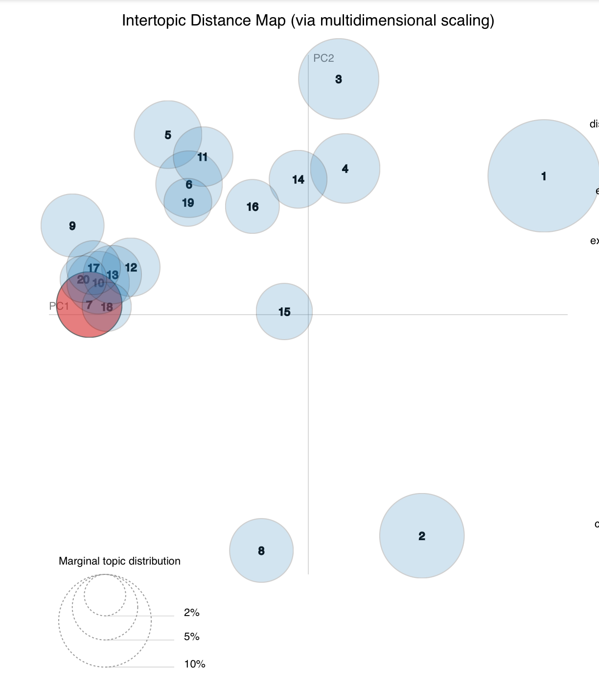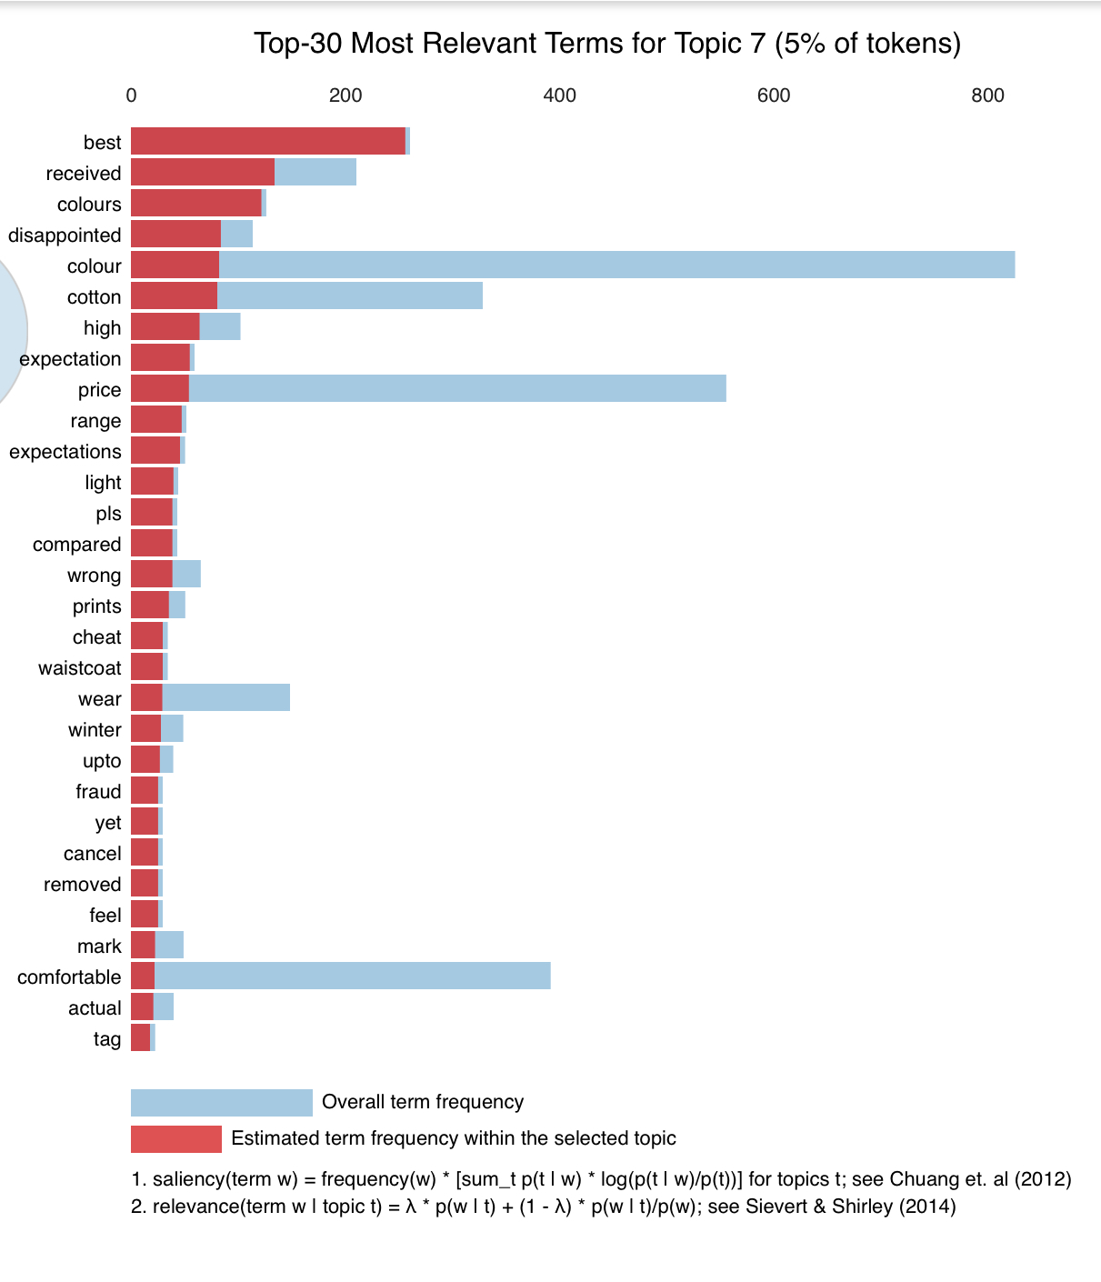

For Topic 8 :

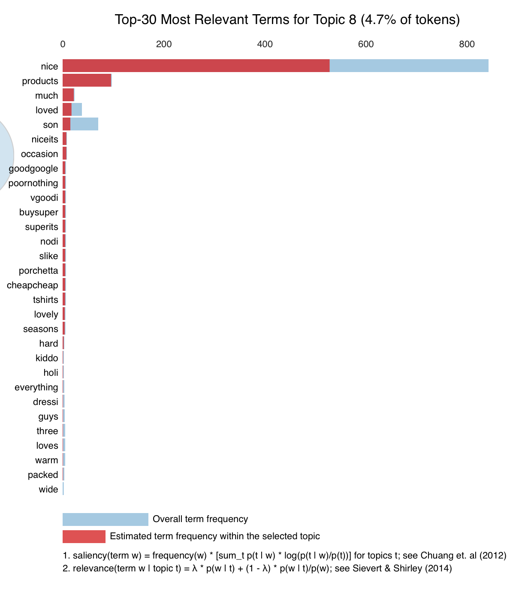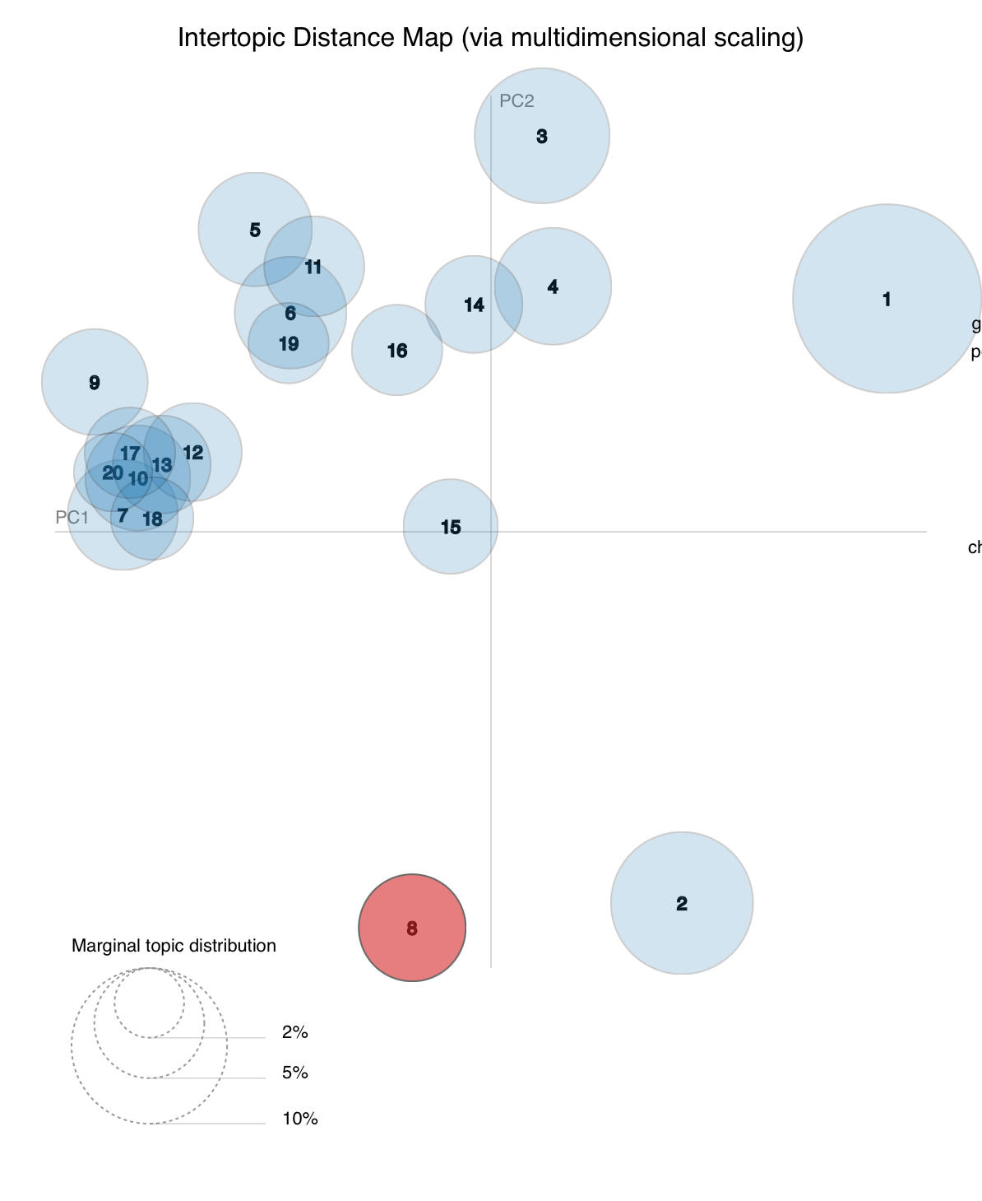

For Topic 9:

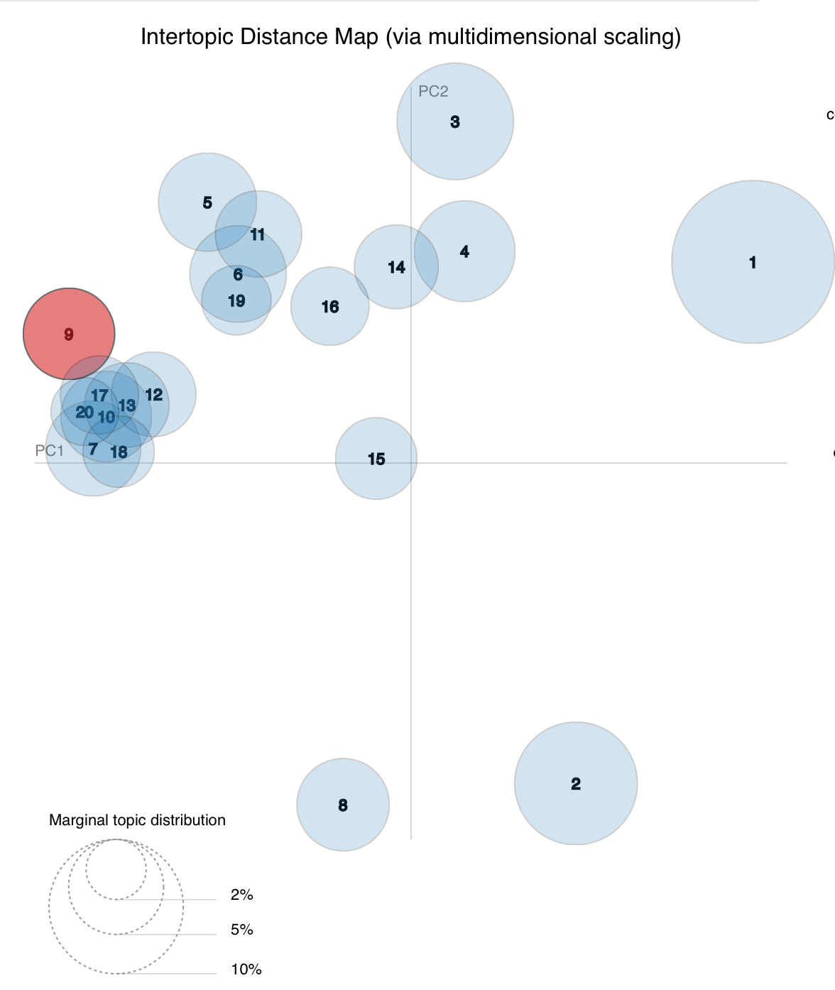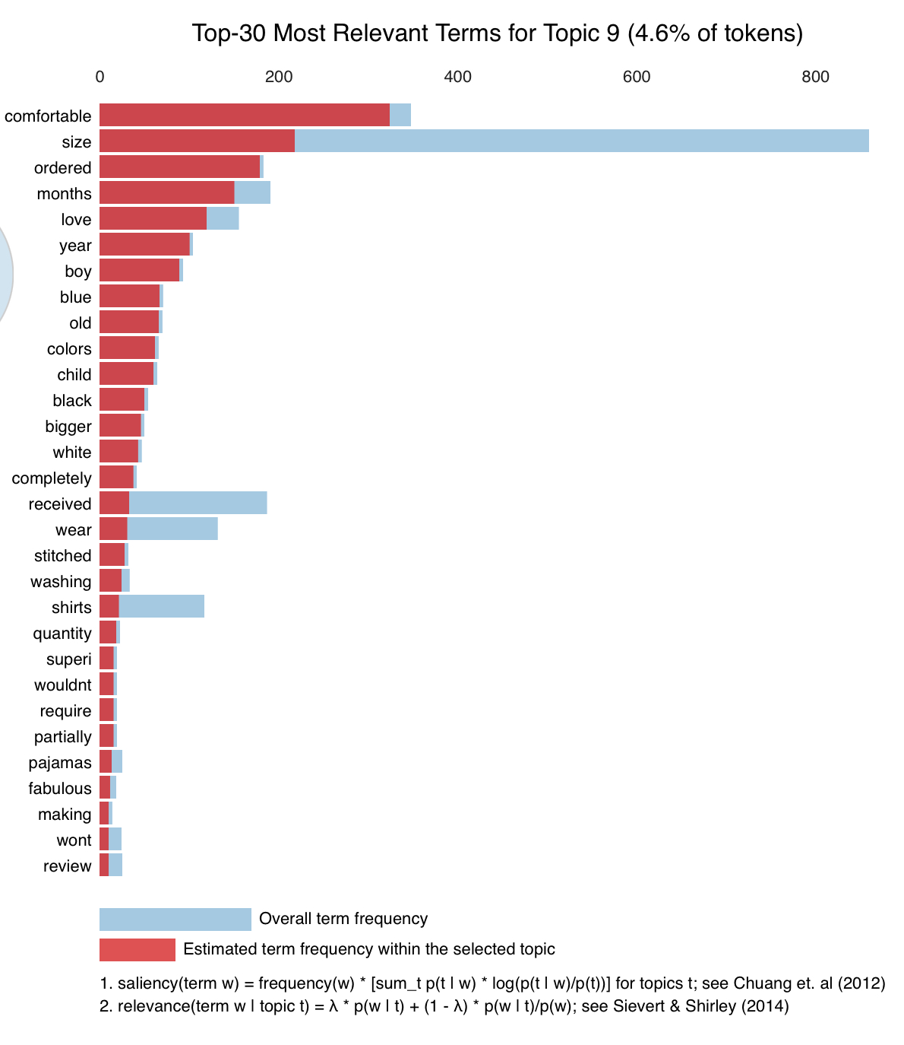

For Topic 10:

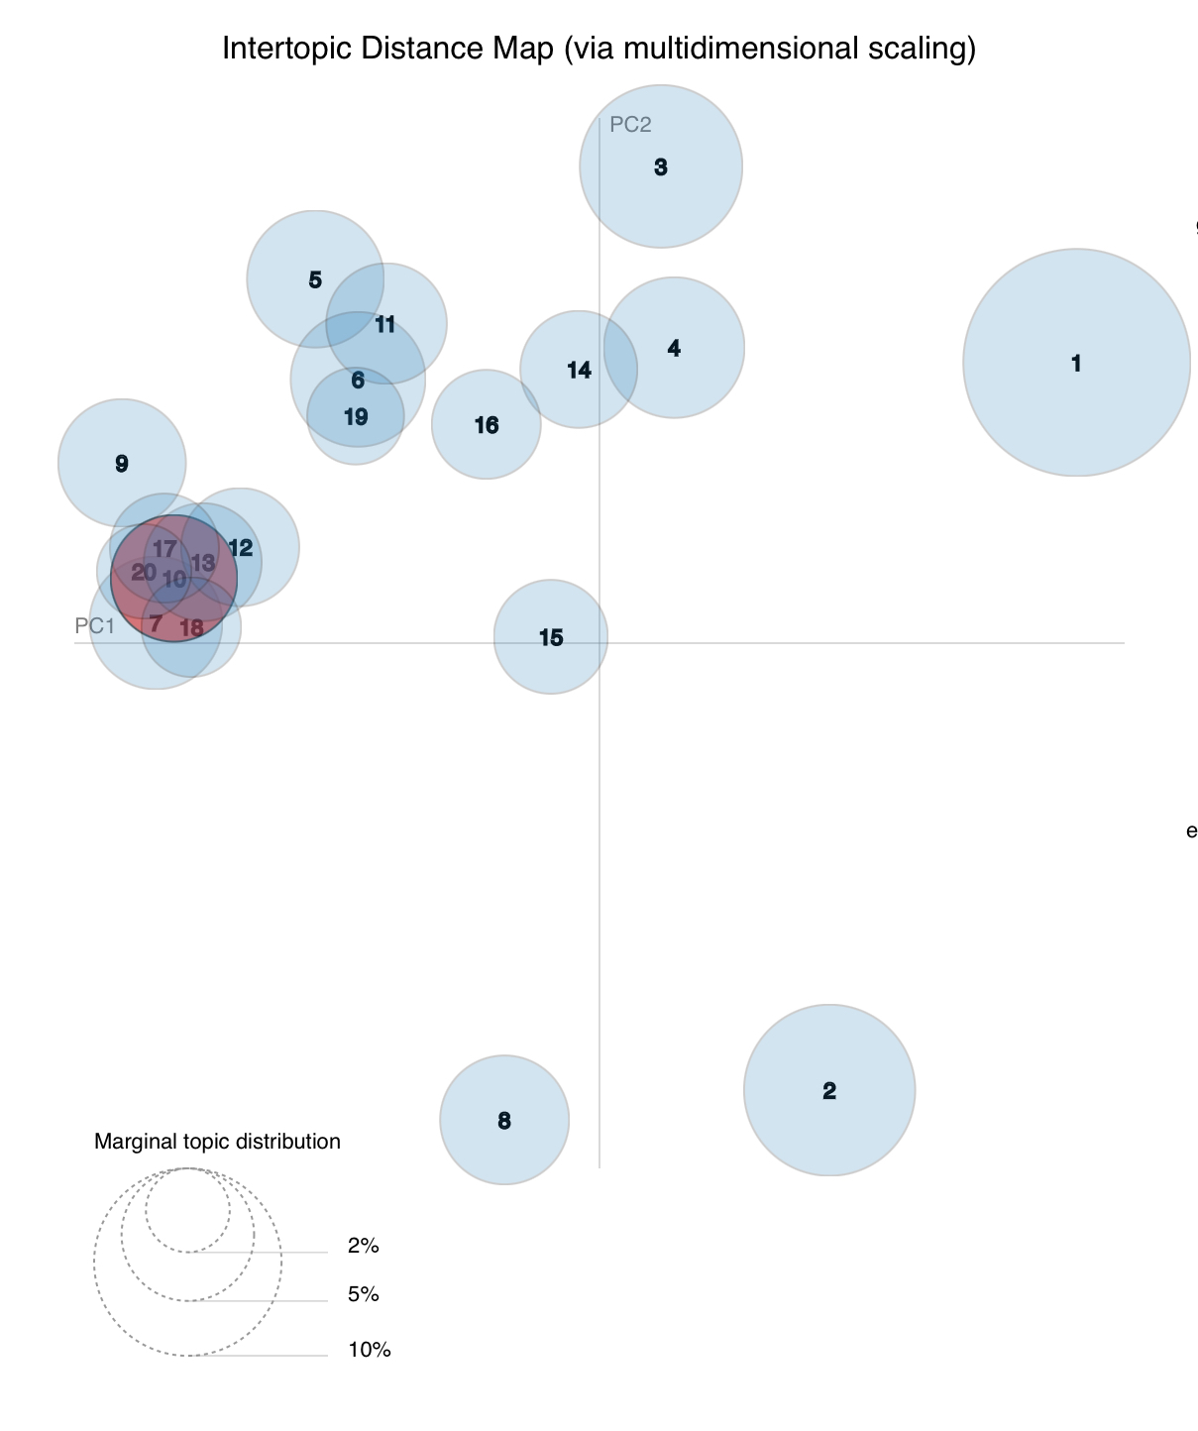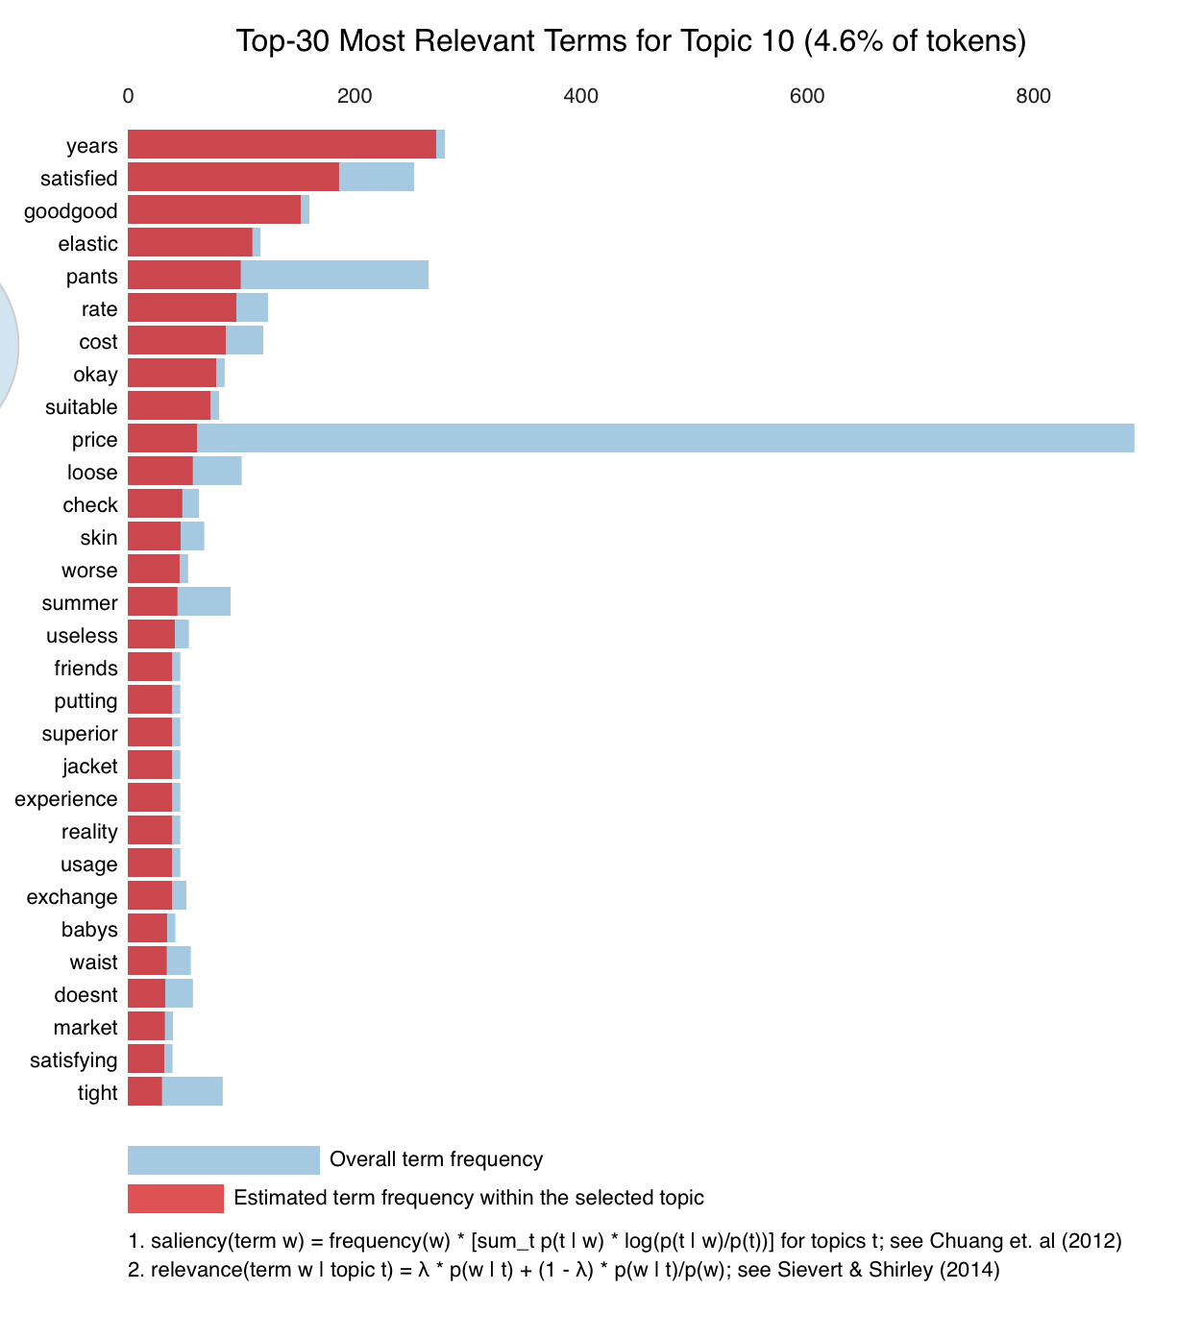

For Topic 11:

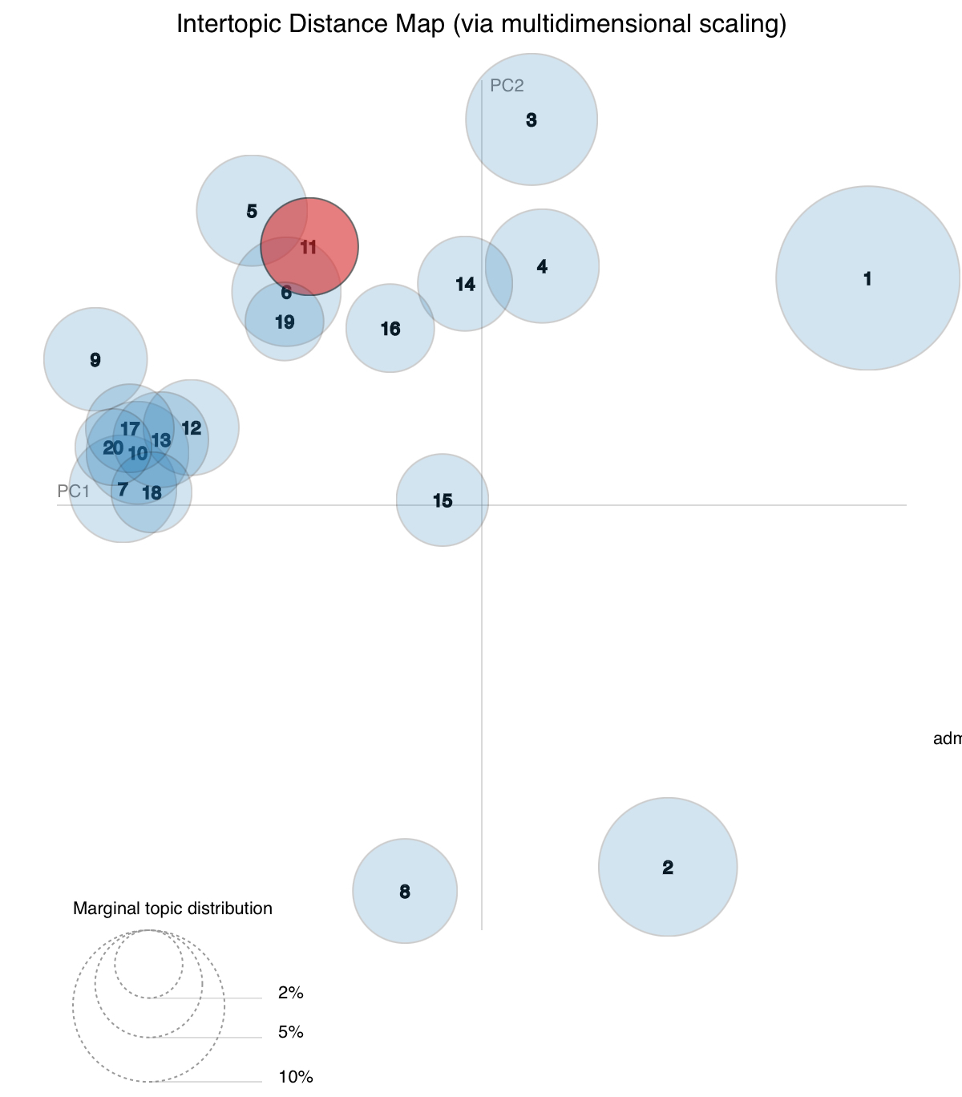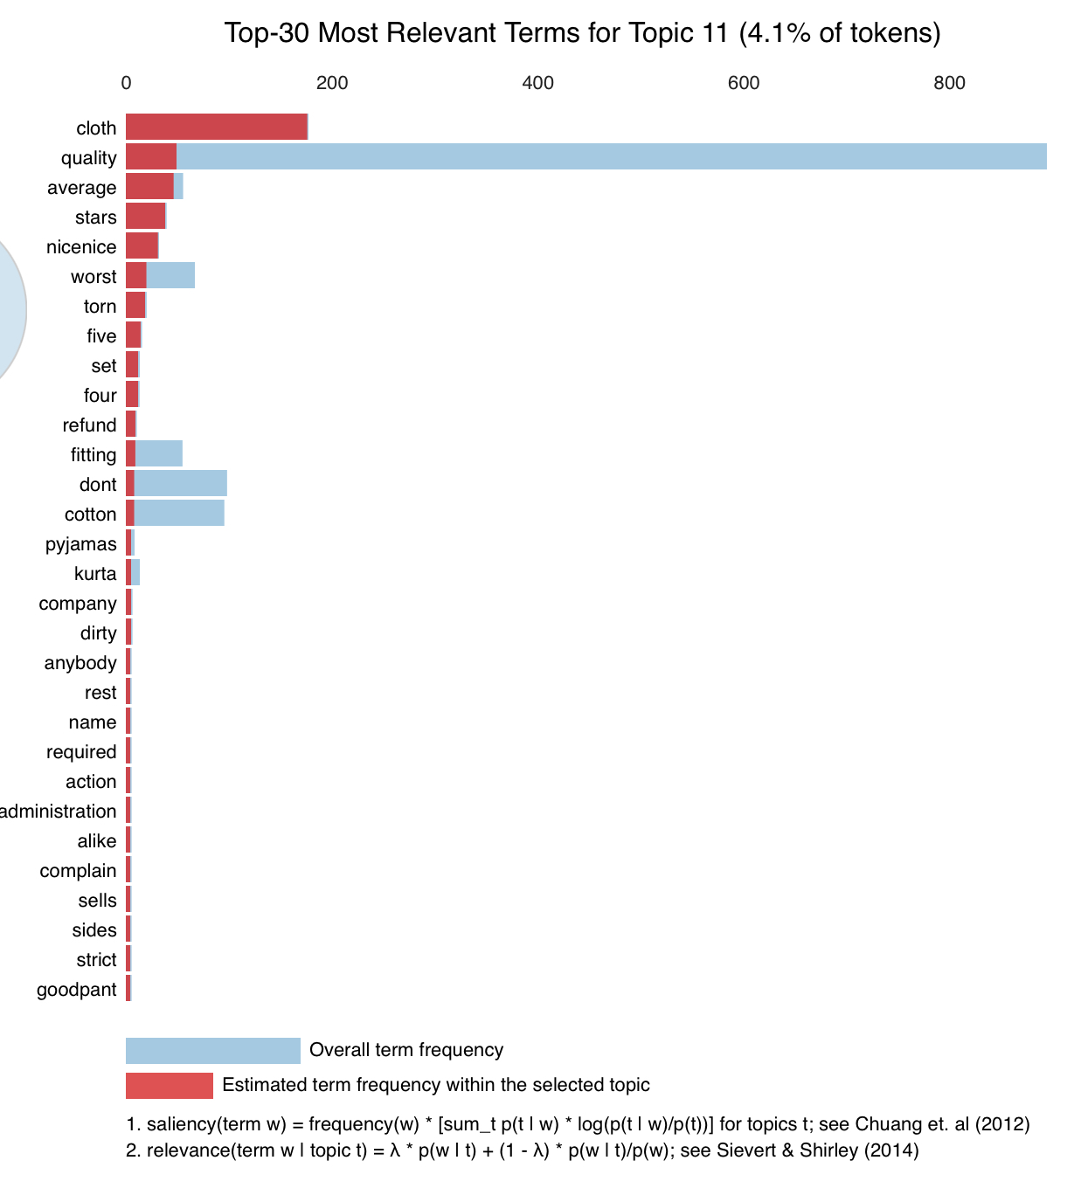

For Topic 12:

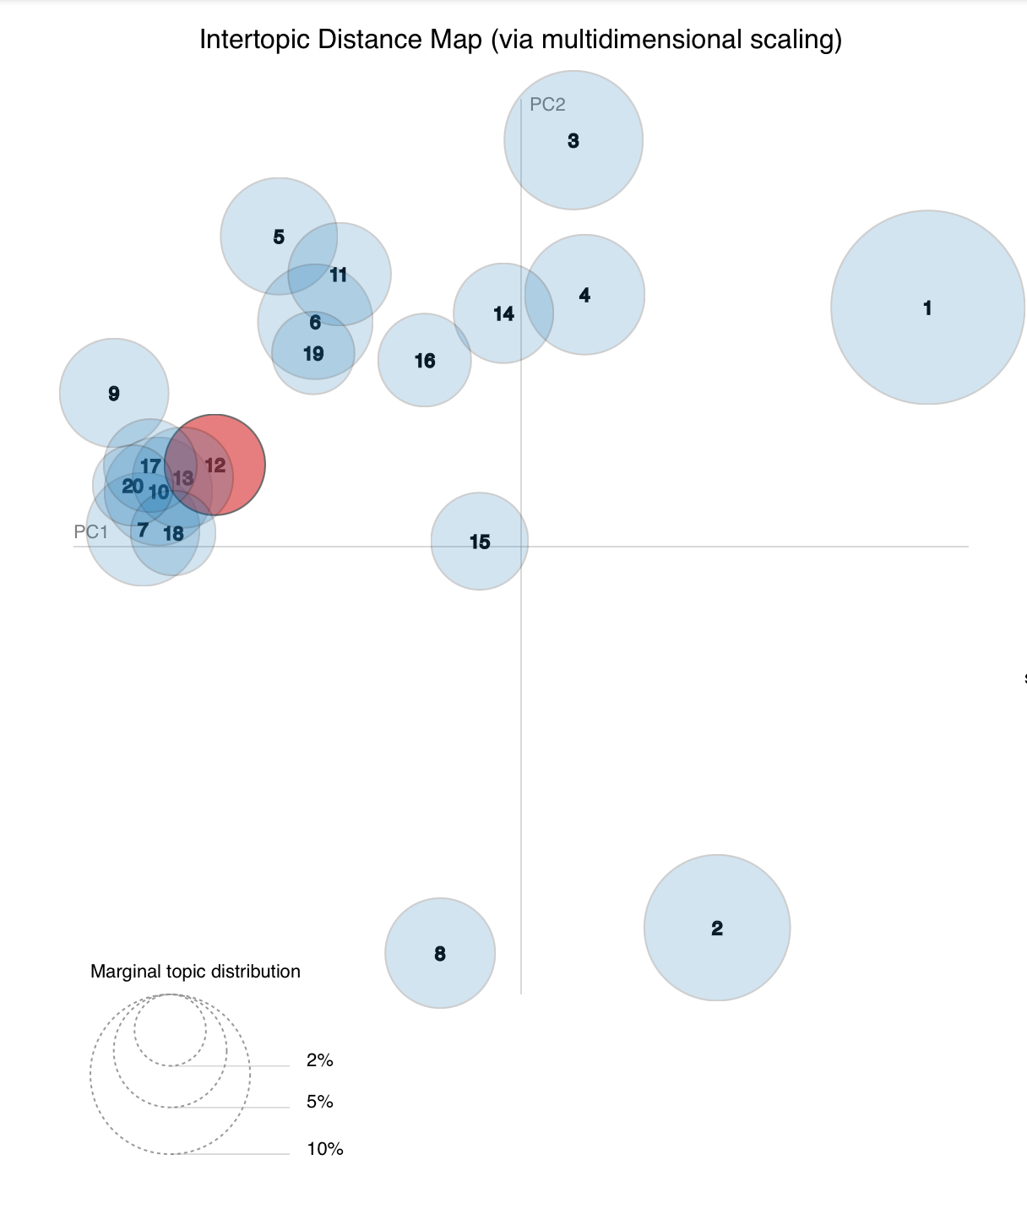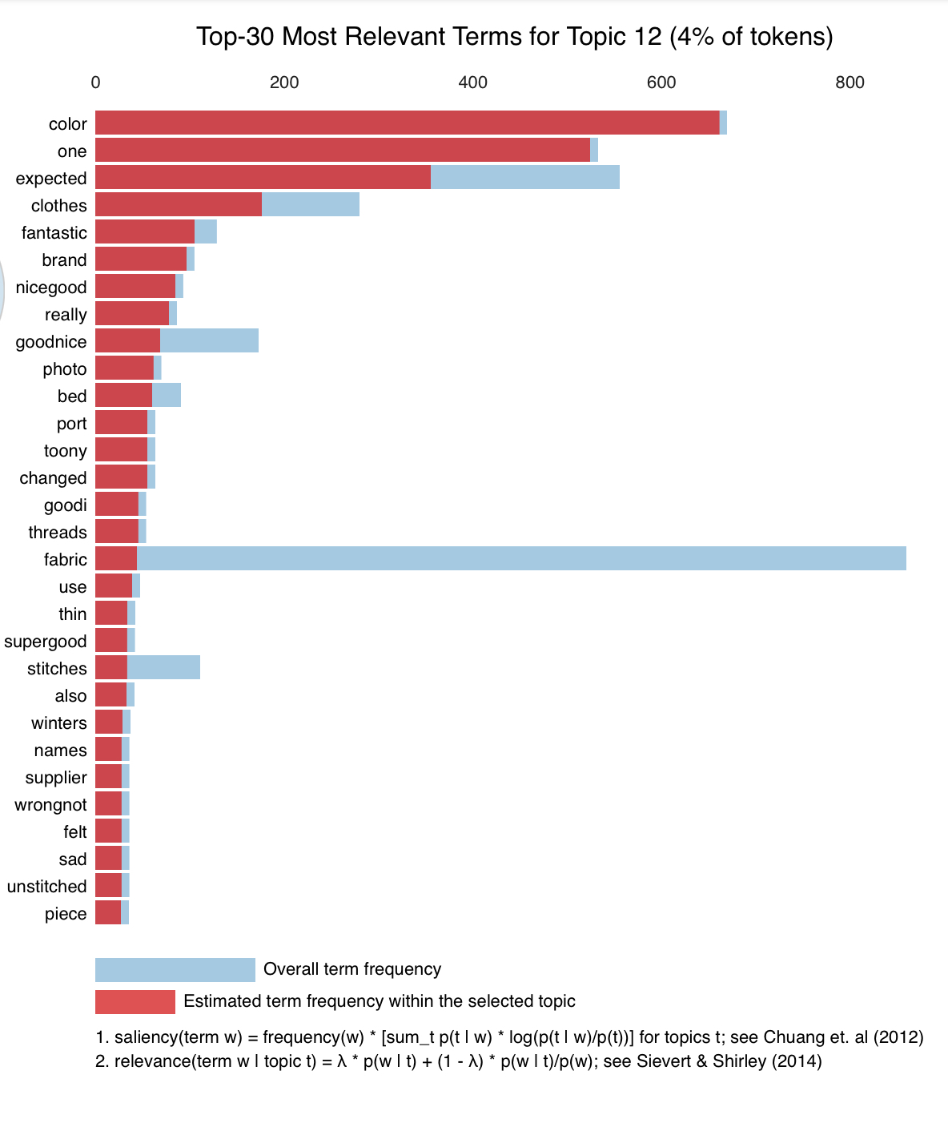

For Topic 13:

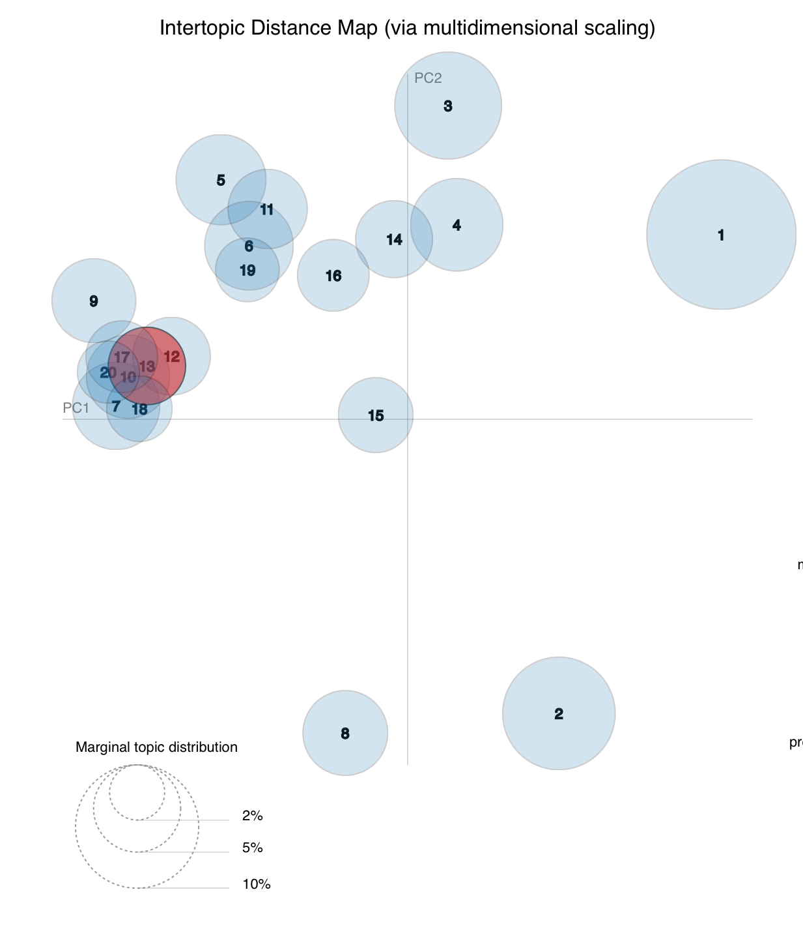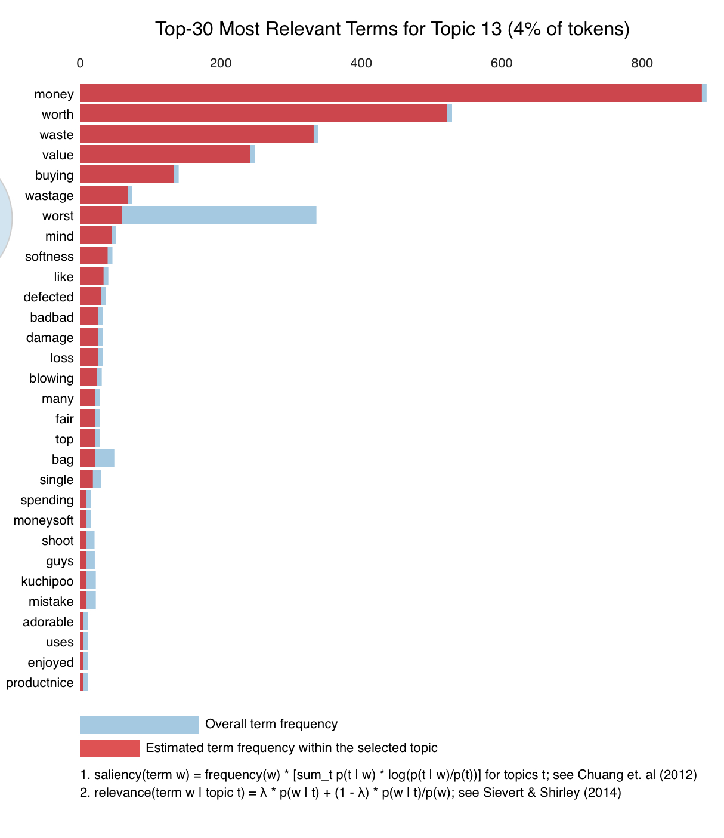

For Topic 14:

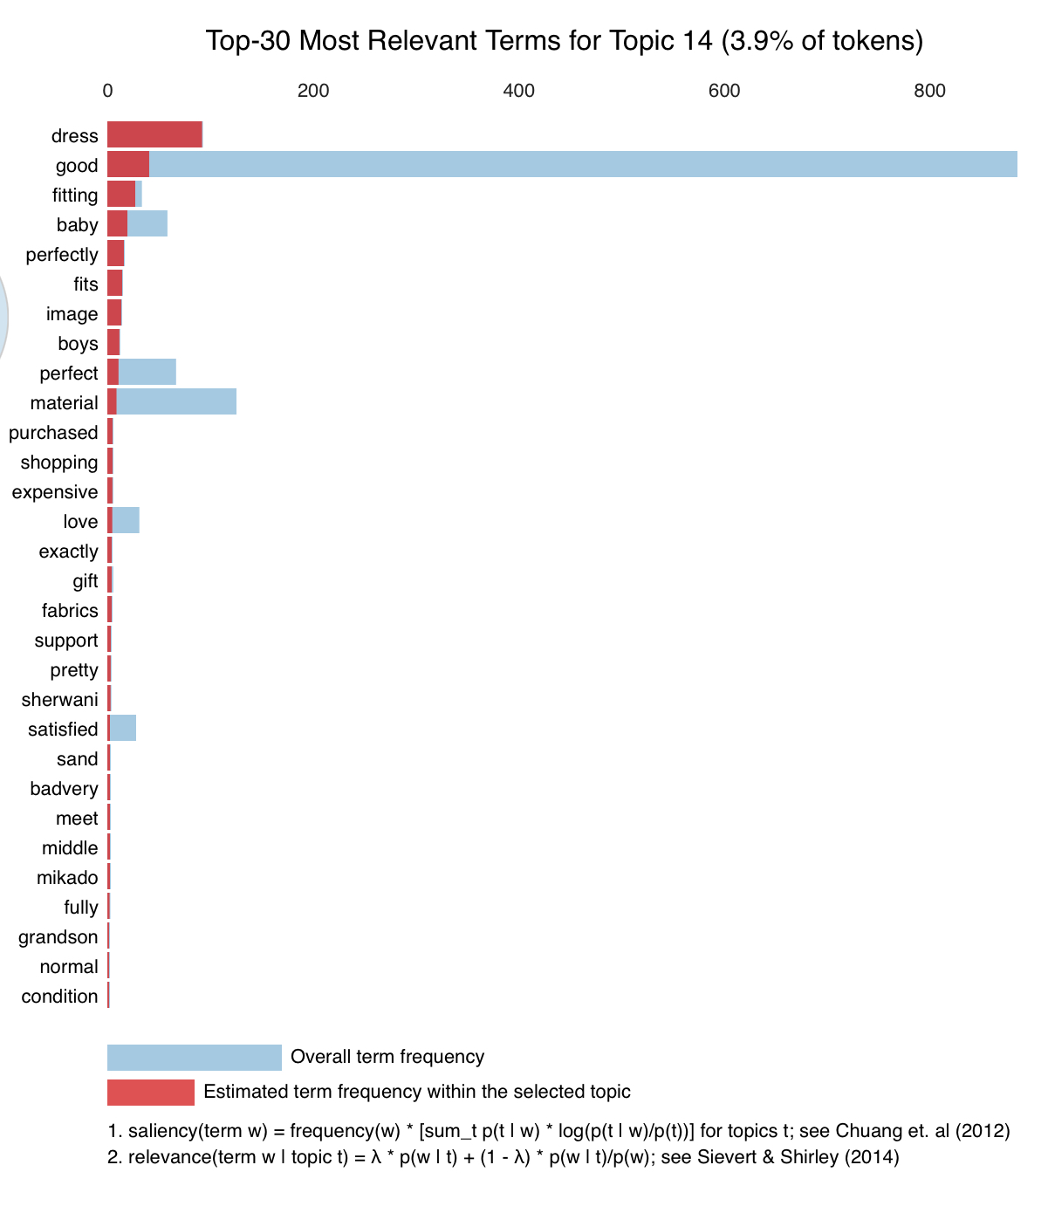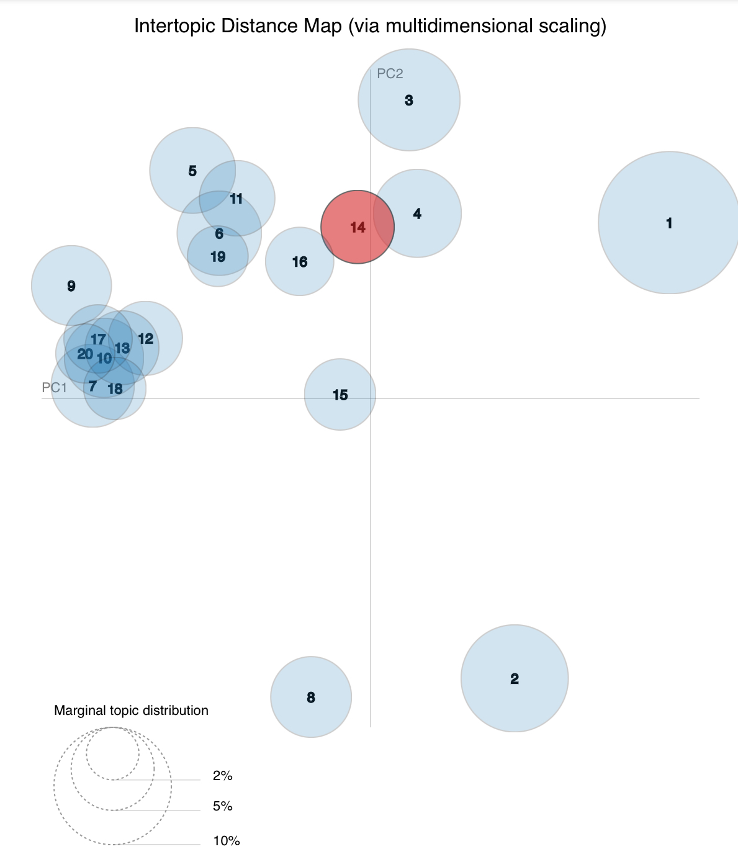

For Topic 15:

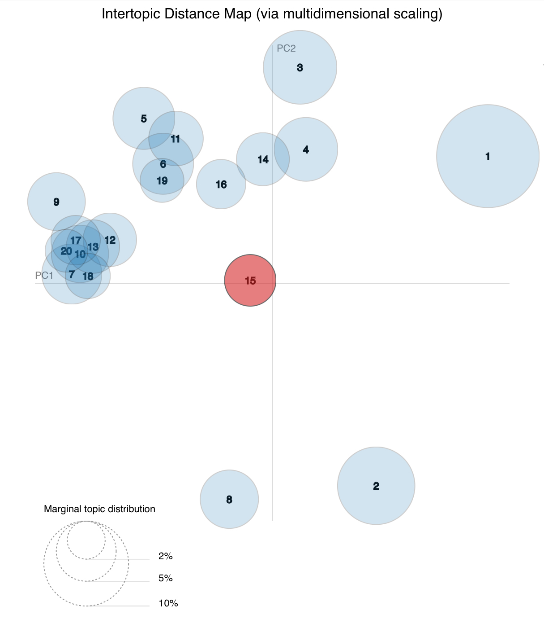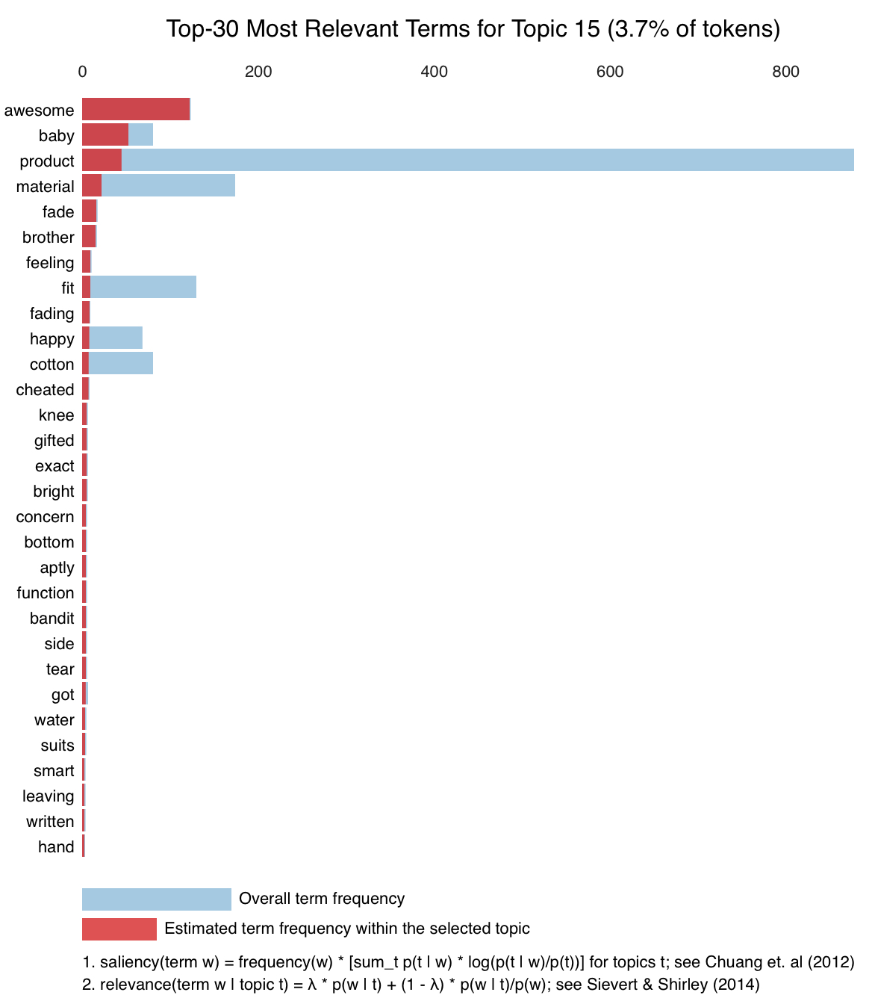

For Topic 16:

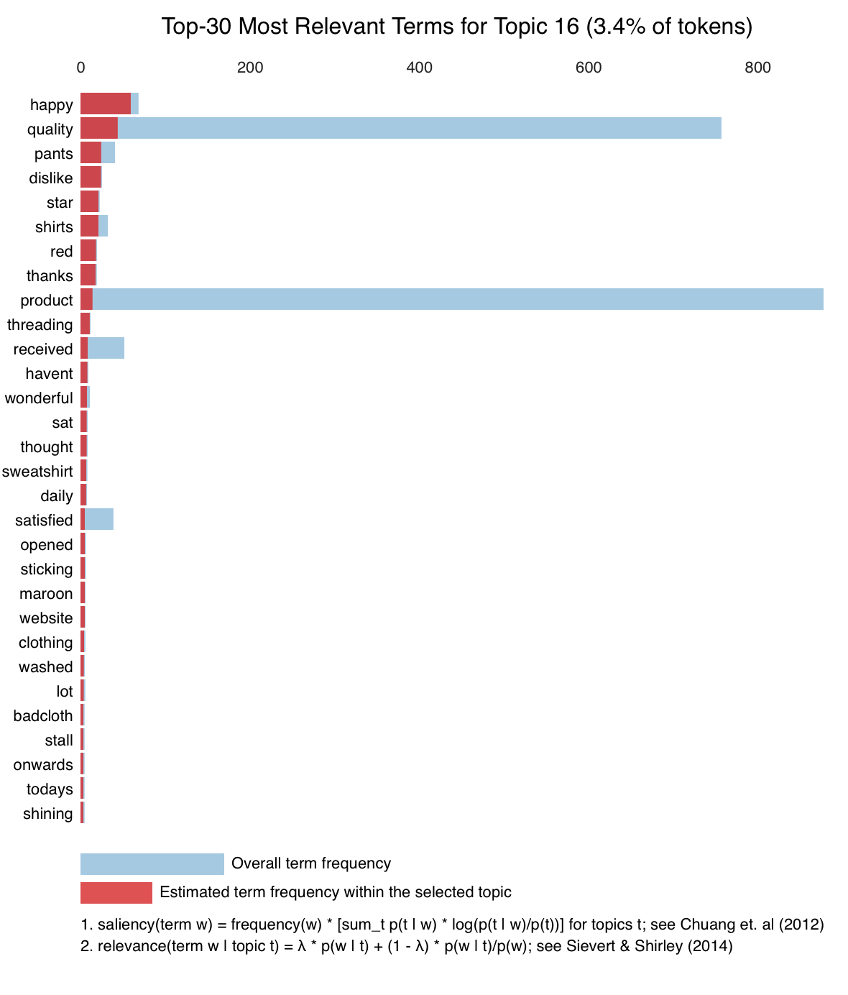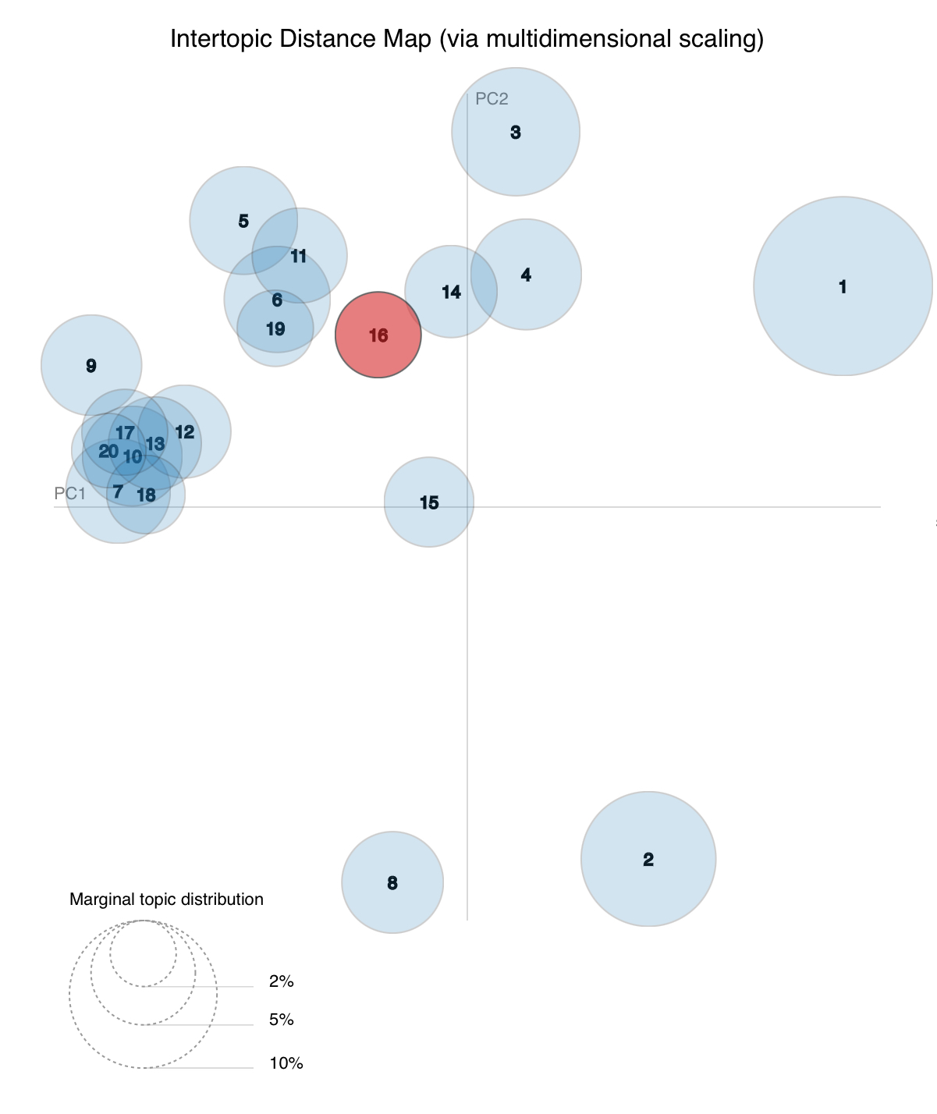

For Topic 17:

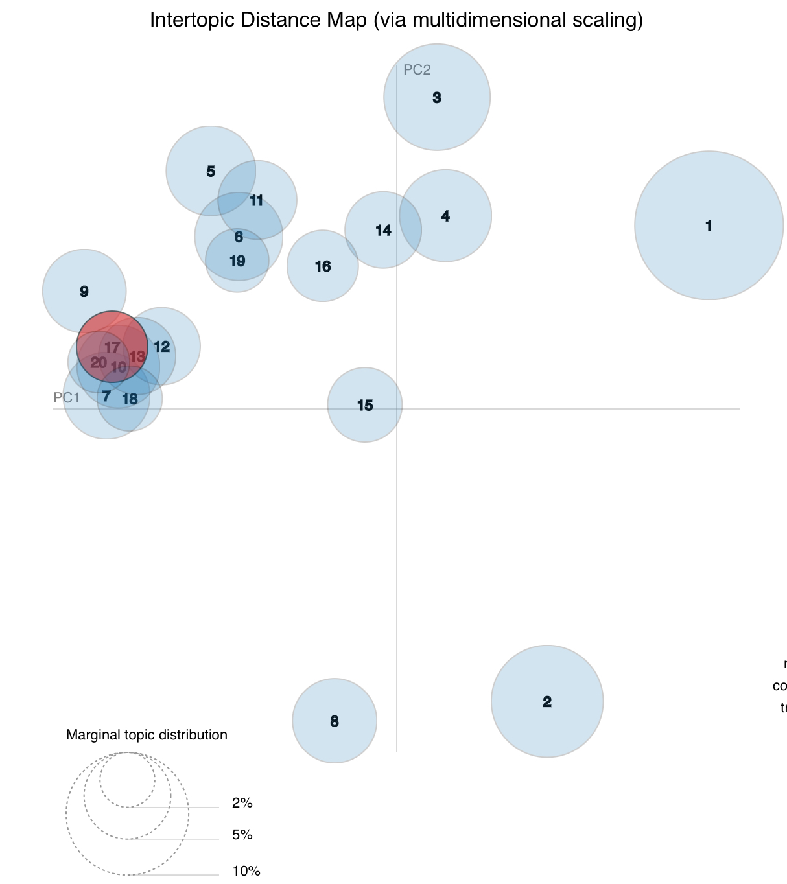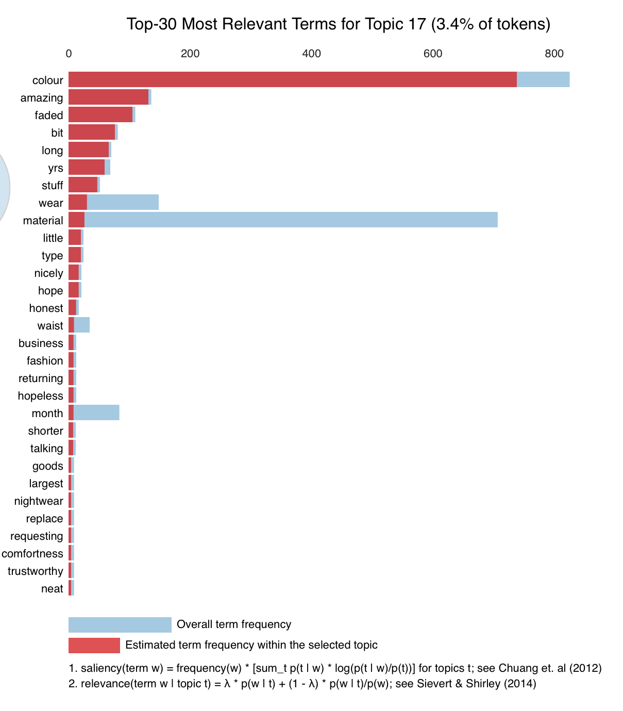

For Topic 18:

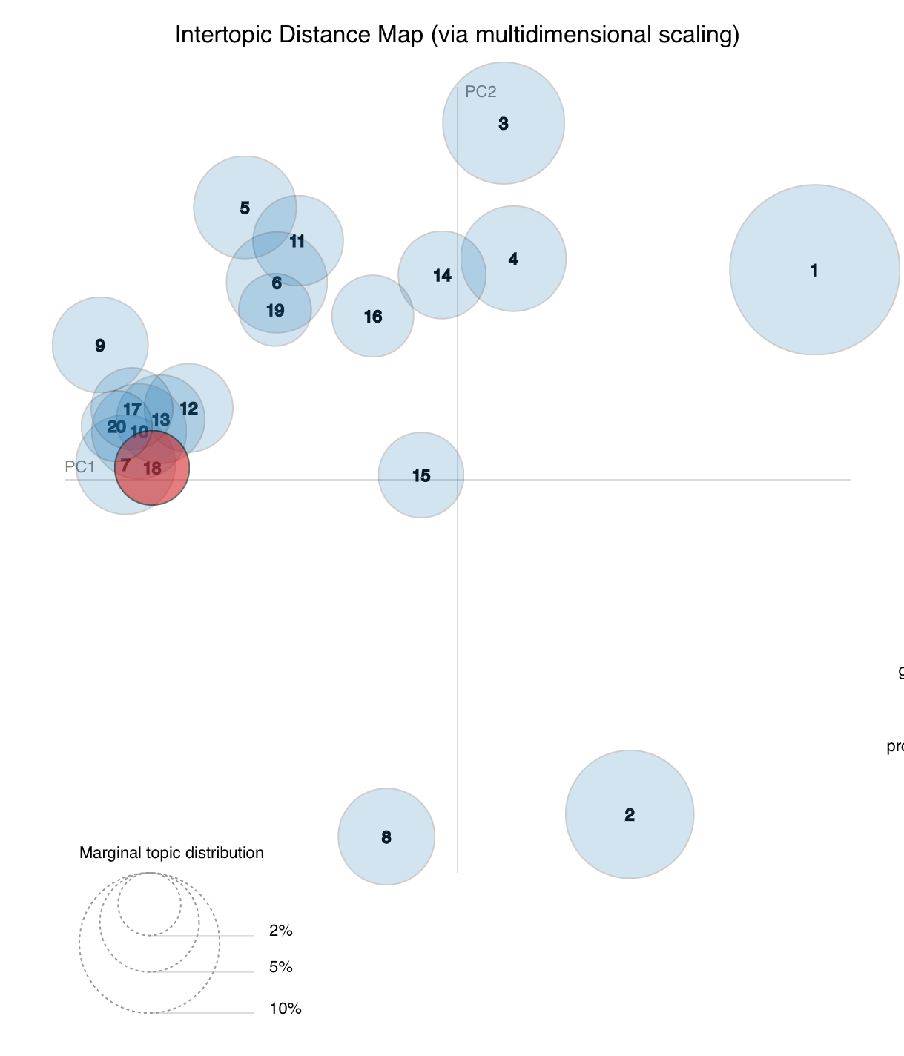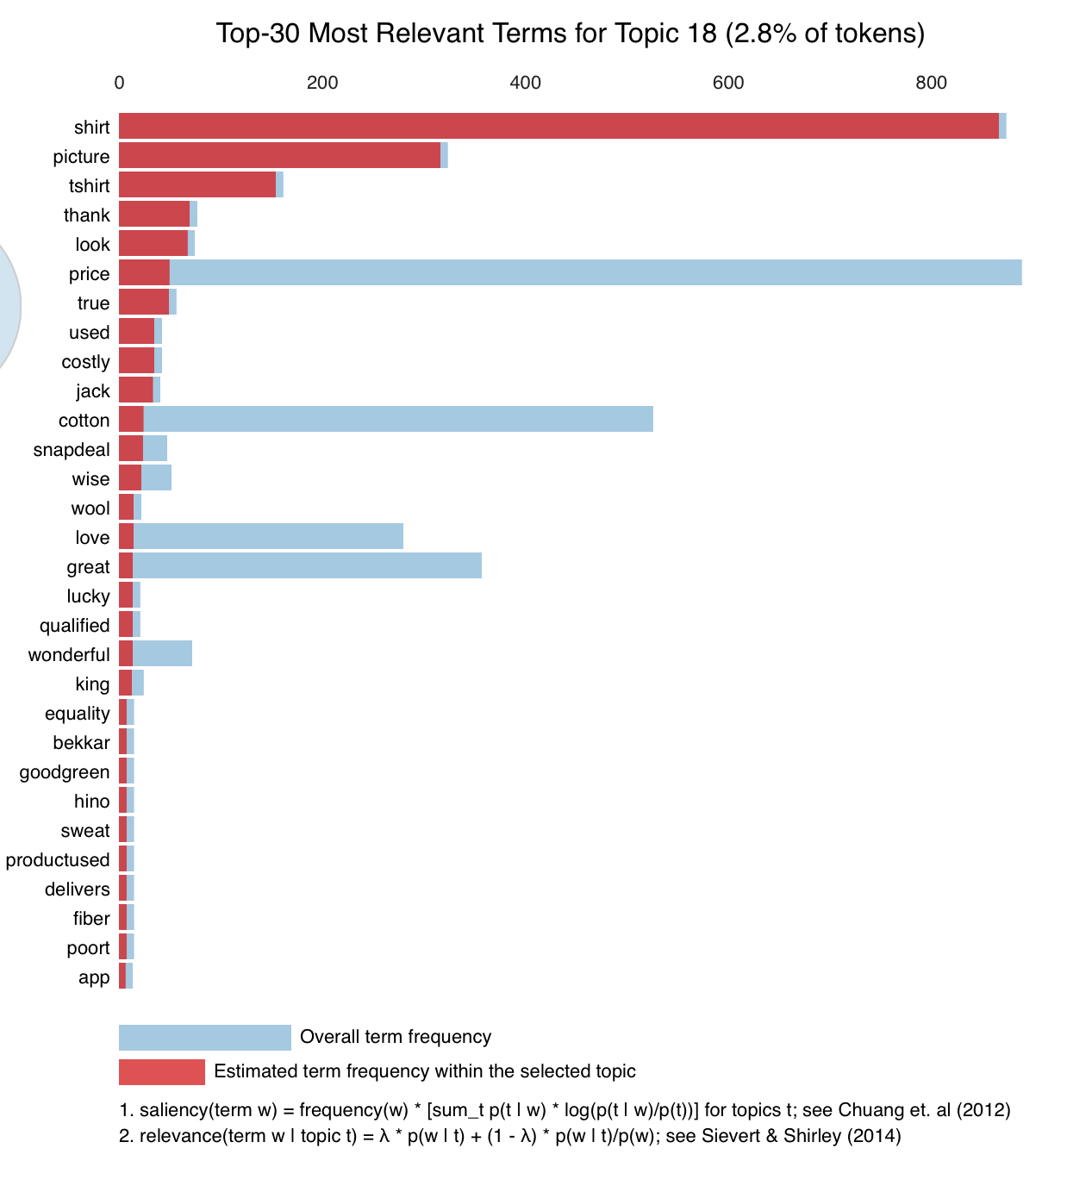

For Topic 19:

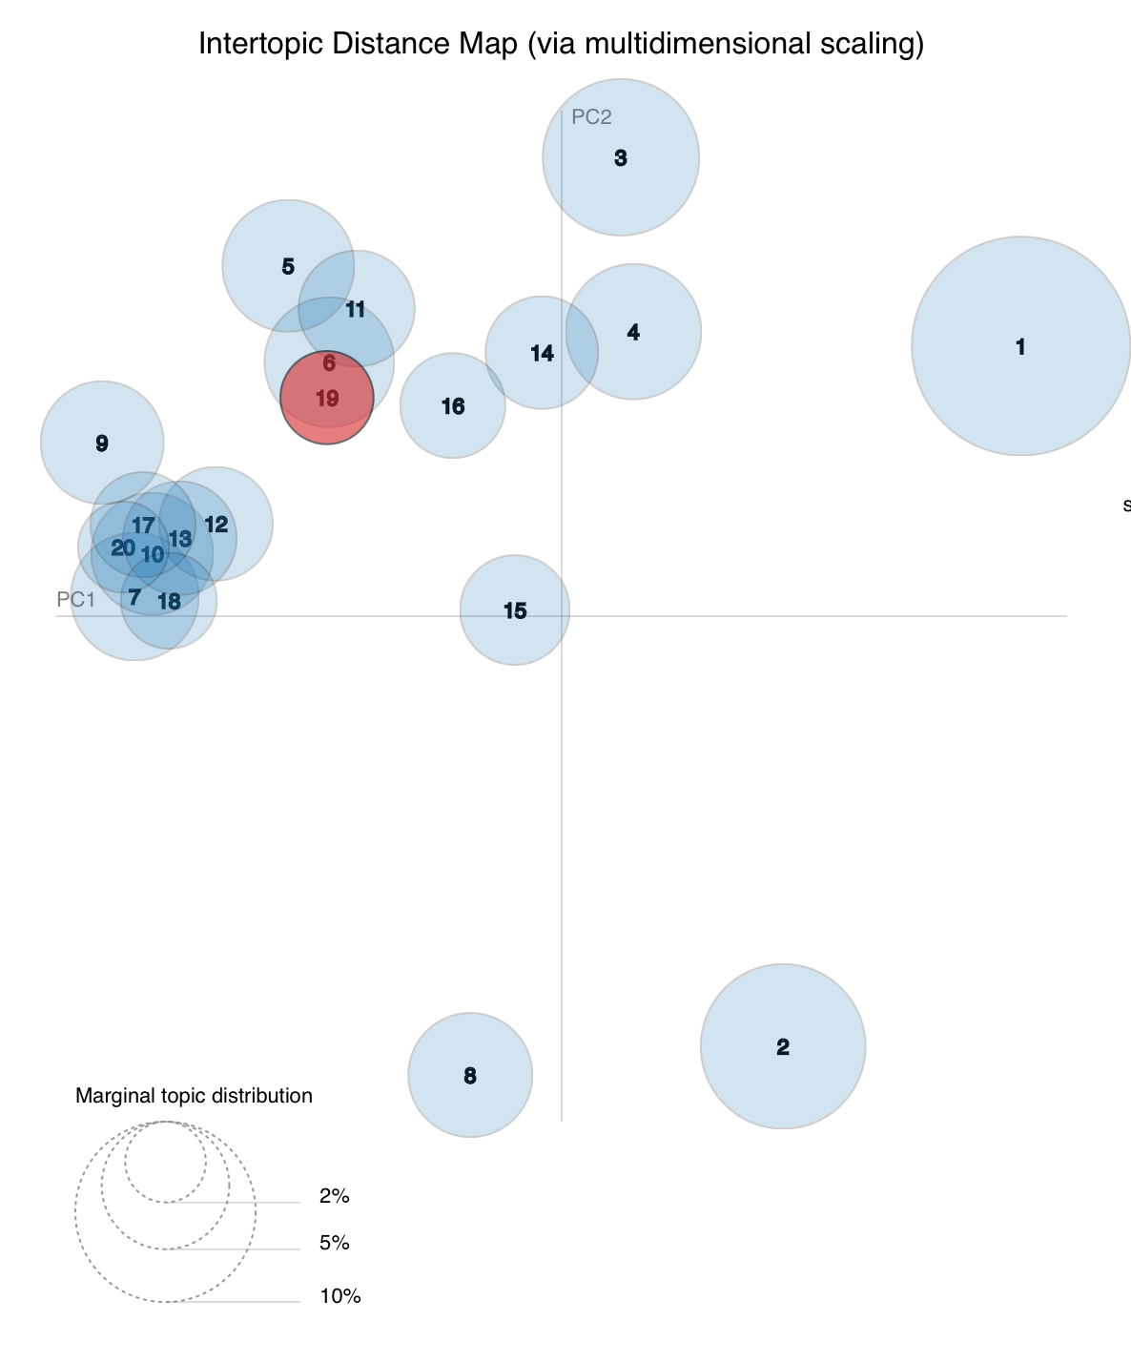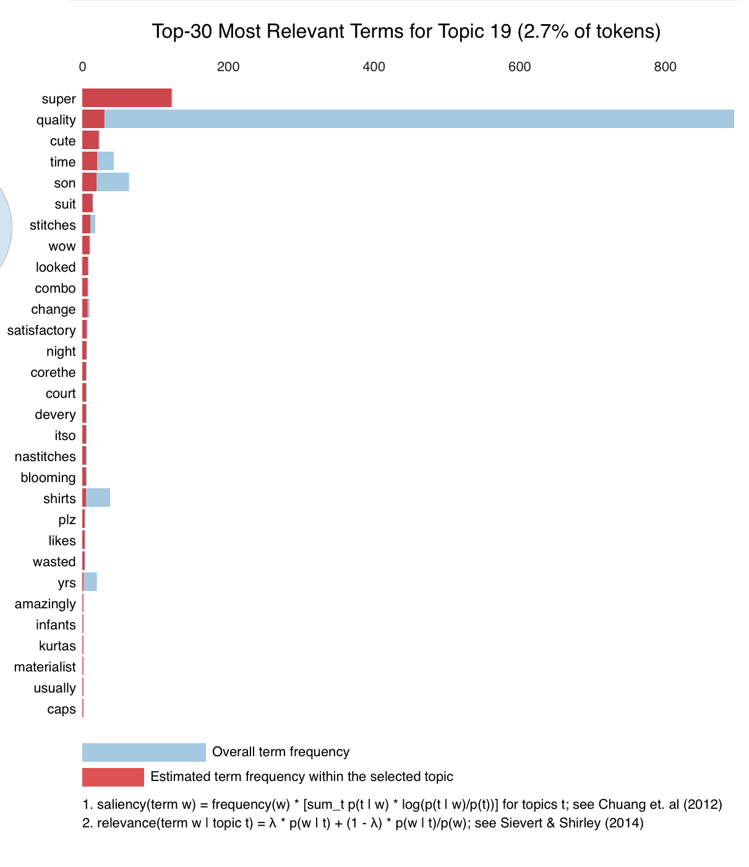

For Topic 20:

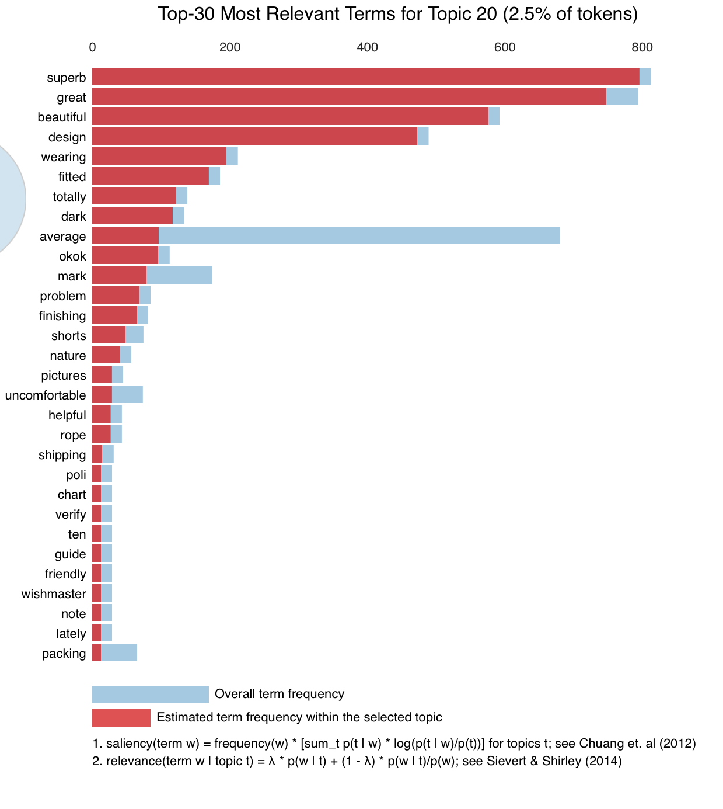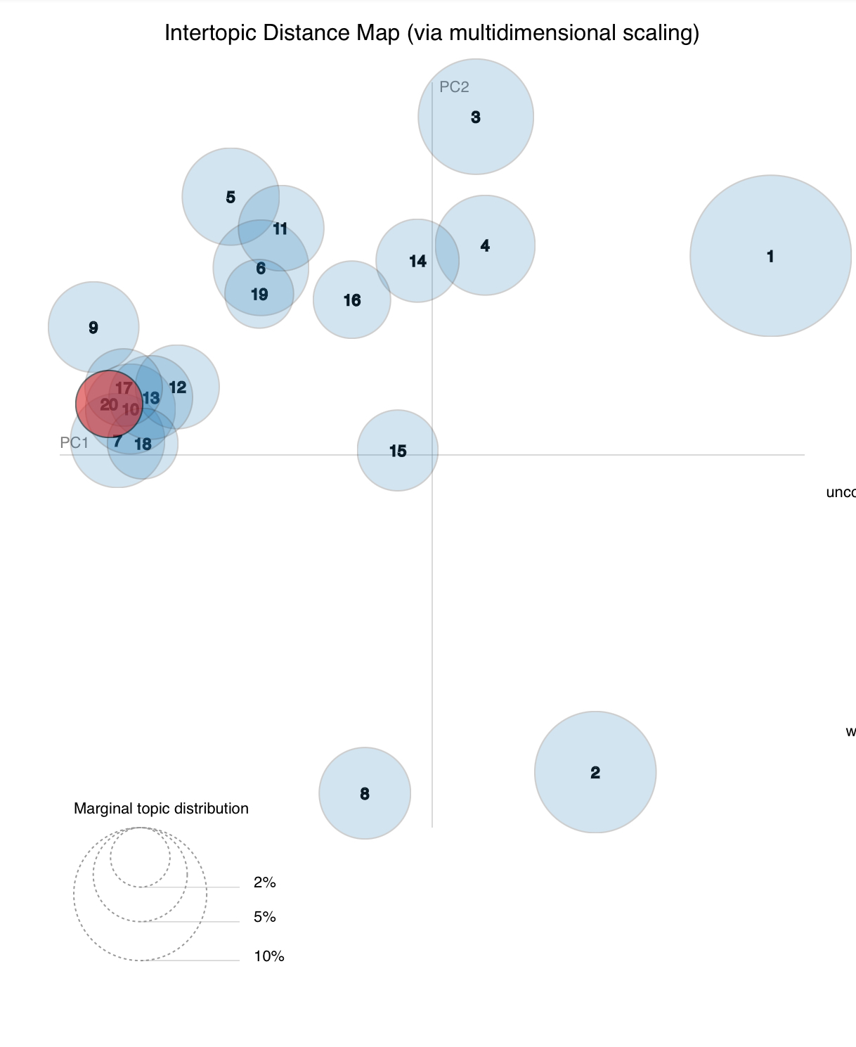

* LDA is an unsupervised technique, meaning that we don’t know prior to running the model how many topics exist in our corpus.You can use the LDA visualization tool pyLDAvis, try a few numbers of topics and compare the results. Topic coherence is one of the main techniques used to estimate the number of topics.We used c_v measure to see the coherence score of our LDA model.

Our coherence score : **0.502092264023399**



* The above plot shows that coherence score increases with the number of topics, with a decline between 20 to 25.Now, choosing the number of topics still depends on your requirement because topics around 20 have good coherence scores but may have repeated keywords in the topic. Topic coherence gives you a good picture so that you can make better decisions.

**Text classification :**

1. Text classification is one of the most important tasks in [Natural Language Processing](https://stackabuse.com/what-is-natural-language-processing/). It is the process of classifying text strings or documents into different categories, depending upon the contents of the strings. Text classification has a variety of applications, such as detecting user sentiment from a tweet, classifying an email as spam or ham, classifying blog posts into different categories, automatic tagging of customer queries, and so on.

Following are the steps required to create a text classification model in Python:

1. Importing Libraries
2. Importing The dataset
3. Text Preprocessing
4. Converting Text to Numbers
5. Training and Test Sets
6. Training Text Classification Model and Predicting Sentiment
7. Evaluating The Model
8. Saving and Loading the Model

Machines, unlike humans, cannot understand the raw text. Machines can only see numbers. Particularly, statistical techniques such as machine learning can only deal with numbers. Therefore, we need to convert our text into numbers.

Different approaches exist to convert text into the corresponding numerical form. The bag of words and the TF IDF Method are two of the most commonly used approaches. In this article, we will use the bag of words model to convert our text to numbers.

**Machine Learning Deployment:**

There are two types of supervised machine learning algorithms: Regression and classification. The former predicts continuous value outputs while the latter predicts discrete outputs.In our case we have implemented using the Python Scikit-Learn library, which is one of the most popular machine learning libraries for Python.

Used libraries :

Import pandas as pd (data manipulation)

import numpy as np(calculations)

import nltk( data preprocessing)

nltk.download('stopwords')

from nltk.corpus import stopwords

from sklearn.feature_extraction.text import CountVectorizer ( Bag of word method)

from sklearn.feature_extraction.text import TfidfTransformer ( TF IDF Method)

Model we used are : Logistic regression , Random forest , Naive Bayes , Support Vector Machine, Multilayer Perceptron Classifier, Bagging , Boosting , Decision Tree, XG Boost

In each figure below : matrix is confusion matrix and in last we have accuracy without cross validation

**Models we used in our study :**

1. **Random Forest Classifier :** Random forests is a supervised learning algorithm. It can be used both for classification and regression. It is also the most flexible and easy to use algorithm. A forest consists of trees. It is said that the more trees it has, the more robust a forest is. Random forests create decision trees on randomly selected data samples, get predictions from each tree and select the best solution by means of voting. It also provides a pretty good indicator of the feature importance.

Package used : from sklearn.ensemble import RandomForestClassifier

1. **Logistic regression :**Logistic Regression is one of the most simple and commonly used Machine Learning algorithms for two-class classification. It is easy to implement and can be used as the baseline for any binary classification problem. Its basic fundamental concepts are also constructive in deep learning. Logistic regression describes and estimates the relationship between one dependent binary variable and independent variables.

Package used :from sklearn.linear_model import LogisticRegression

1. **Naive bayes:** Naive Bayes is the most straightforward and fast classification algorithm, which is suitable for a large chunk of data. Naive Bayes classifier is successfully used in various applications such as spam filtering, text classification, sentiment analysis, and recommender systems. It uses Bayes theorem of probability for prediction of unknown class.

Package used :from sklearn.naive_bayes import GaussianNB

1. **SVM :** Generally, Support Vector Machines is considered to be a classification approach, but can be employed in both types of classification and regression problems. It can easily handle multiple continuous and categorical variables. SVM constructs a hyperplane in multidimensional space to separate different classes. SVM generates optimal hyperplanes in an iterative manner, which is used to minimize an error. The core idea of SVM is to find a maximum marginal hyperplane(MMH) that best divides the dataset into classes.

Package name : from sklearn import svm

1. **Bagging :**Bagging is one of the Ensemble construction techniques which is also known as Bootstrap Aggregation. Bootstrap establishes the foundation of Bagging technique. Bootstrap is a sampling technique in which we select “n” observations out of a population of “n” observations. But the selection is entirely random, i.e., each observation can be chosen from the original population so that each observation is equally likely to be selected in each iteration of the bootstrapping process.

Package name :from sklearn.ensemble import BaggingClassifier

1. **Boosting :**Boosting is a form of *sequential learning* technique. The algorithm works by training a model with the entire training set, and subsequent models are constructed by fitting the residual error values of the initial model. In this way, Boosting attempts to give higher weight to those observations that were poorly estimated by the previous model.

Package used : from sklearn.ensemble import GradientBoostingClassifier

1. **Multilayer perceptron classifier** :MLPC stands for Multi-layer Perceptron classifier which in the name itself connects to a Neural Network. Unlike other classification algorithms such as Support Vectors or Naive Bayes Classifier, MLPClassifier relies on an underlying Neural Network to perform the task of classification.

Package used :from sklearn.neural_network import MLPClassifier

1. **XGBoost :**xgboost is a decision-tree-based ensemble Machine Learning algorithm that uses a gradient boosting framework. In prediction problems involving unstructured data (images, text, etc.) artificial neural networks tend to outperform all other algorithms or frameworks. However, when it comes to small-to-medium structured/tabular data, decision tree based algorithms are considered best-in-class right now.

Package used :from xgboost import XGBClassifier

1. **Decision tree :** A decision tree is a flowchart-like tree structure where an internal node represents a feature(or attribute), the branch represents a decision rule, and each leaf node represents the outcome. The topmost node in a decision tree is known as the root node. It learns to partition on the basis of the attribute value. It partitions the tree in a recursive manner called recursive partitioning. This flowchart-like structure helps you in decision making. It's visualized like a flowchart diagram which easily mimics human level thinking. That is why decision trees are easy to understand and interpret.

Package used :from sklearn.tree import DecisionTreeClassifier

|  |
| --- |
| Table 1: Comparisons between different algorithm for bag of words method |

|  |  |  |  |  |  |
| --- | --- | --- | --- | --- | --- |
| **Model** | **Accuracy** | **Precision** | **Recall** | **F1 Score** | **Specificity** |
| Random Forest | 86.333% | NR :0.87  R:0.80 | NR :0.82  R: 0.85 | NR : 0.84  R: 0.82 | 0.80701 |
| Logistic Regression | 86% | NR :0.88  R:0.90 | NR : 0.92  R:0.85 | NR : 0.90  R: 0.88 | 0.90384 |
| Naive Bayes | 86.33% | NR :0.94  R:0.75 | NR : 0.74  R: 0.95 | NR : 0.83  R:0.84 | 0.8679 |
| SVM | 82% | NR : 0.86  R: 0.94 | NR : 0.95  R: 0.82 | NR : 0.91  R:0.87 | 0.9375 |
| Bagging | 81.66% | NR : 0.88  R: 0.76 | NR :0.77  R: 0.87 | NR :0.82  R:0.81 | 0.7967 |
| Boosting | 86.67% | NR :0.87  R: 0.87 | NR :0.89  R:0.84 | NR : 0.88  R: 0.85 | 0.8679 |
| MLP | 86.66% | NR : 0.87  R: 0.86 | NR :0.89  R: 0.84 | NR : 0.88  R: 0.85 | 0.867 |
| Decision Tree | 61.5% | NR : 0.91  R: 0.76 | NR :0.97  R:0.49 | NR : 0.81  R: 0.64 | 0.9310 |
| XG Boost | 84.16% | NR : 0.88  R: 0.76 | NR : 0.77  R: 0.87 | NR : 0.82  R: 0.81 | 0.762 |

|  |
| --- |
| Table 2: Comparison of different algorithm for TF IDF Method |

|  |  |  |  |  |  |
| --- | --- | --- | --- | --- | --- |
| **Model** | **Accuracy** | **Precision** | **Recall** | **F1 Score** | **Specificity** |
| Random Forest | 85% | NR :0.86  R: 0.81 | NR :0.83  R: 0.84 | NR : 0.84  R: 0.82 | 0.80701 |
| Logistic Regression | 83.5% | NR :0.88  R:0.90 | NR : 0.92  R:0.85 | NR : 0.90  R: 0.88 | 0.90384 |
| Naive Bayes | 79.5% | NR :0.94  R:0.75 | NR : 0.74  R: 0.95 | NR : 0.83  R:0.84 | 0.8679 |
| SVM | 84.5% | NR : 0.86  R: 0.94 | NR : 0.95  R: 0.82 | NR : 0.91  R:0.87 | 0.9375 |
| Bagging | 82.5% | NR : 0.87  R: 0.80 | NR :0.82  R: 0.85 | NR :0.84  R:0.82 | 0.7967 |
| Boosting | 81.33% | NR :0.87  R: 0.87 | NR :0.89  R:0.84 | NR : 0.88  R: 0.85 | 0.8679 |
| MLP | 81.33% | NR : 0.87  R: 0.86 | NR :0.89  R: 0.84 | NR : 0.88  R: 0.85 | 0.867 |
| Decision Tree | 71.33% | NR : 0.68  R: 0.93 | NR :0.97  R:0.47 | NR : 0.80  R: 063 | 0.9285 |
| XG Boost | 85% | NR : 0.91  R: 0.76 | NR : 0.75  R: 0.91 | NR : 0.82  R: 0.83 | 0.762 |

Coefficient for logistic regression :-0.2838945330636306

Intercept :[1.26821553]

**Hyperparameters for each model :**

1. **Random Forest**

|  |  |
| --- | --- |
| **Parameters** | **Selection** |
| bootstrap | True |
| ccp_alpha | 0 |
| weight | None |
| Criterion | gini |
| max_width | none |
| max_feature | auto |
| max_leaf_node | none |
| max_samples | none |
| min_impurity_decrease | 0.0 |
| min_impurity_spli | none |
| max_samples_leaf | 1 |
| max_samples_splits | 2 |
| min_weight_fraction_leaf | 0 |
| n_estimators | 1000 |
| n_jobs | none |
| Random _state | 0 |

1. **Logistic regression :**

|  |  |
| --- | --- |
| **Parameters** | **Selection** |
| C | 1.0 |
| class_weight | none |
| dual | false |
| fit_intercept | true |
| intercept_scaling | 1 |
| I1_ratio | none |
| max_iteration | 100 |
| multi_class | auto |
| penalty | I2 |
| tol | 0.0001 |
| solver | lbfgs |
| n_jobs | none |
| Random _state | none |

1. **Support Vector Machine**

|  |  |
| --- | --- |
| **Parameters** | **Selection** |
| C | 1 |
| break_ties | false |
| cache_size | 200 |
| class_weight | None |
| coeff0 | 0 |
| decision_func_shape | ovr |
| degree | 3 |
| gamma | scale |
| kernel | rbf |
| max_iter | -1 |
| probability | false |
| random_state | None |
| tol | 0.001 |

1. **Naive bayes**

|  |  |
| --- | --- |
| **Parameters** | **Selection** |
| priors | None |
| var_smoothing | 1e-09 |

1. **Bagging**

|  |  |
| --- | --- |
| **Parameters** | **Selection** |
| base_estimator | None |
| bootstrap | true |
| bootstrap_feature | false |
| max_features | 1 |
| max_samples | 1 |
| n_estimator | 10 |
| n_jobs | None |
| random_state | None |
| Verbose | 0 |

1. **Boosting :**

|  |  |
| --- | --- |
| **Parameters** | **Selection** |
| n_estimators | 100 |
| learning_rate | 1 |
| max_depth | 1 |
| random_state | 0 |

1. **Multi-layer perceptron classifier**

|  |  |
| --- | --- |
| **Parameters** | **Selection** |
| hidden_layer_sizes | 150,100,50 |
| max_iter | 300 |
| activation | relu |
| solver | adam |
| random_state | 1 |

1. **XGBoost**

|  |  |
| --- | --- |
| **Parameters** | **Selection** |
| colsample_bytree | 0.3 |
| learning_rate | 0.1 |
| max_depth | 5 |
| alpha | 10 |
| n_estimators | 10 |

1. **Decision Tree**

|  |  |
| --- | --- |
| **Parameters** | **Selection** |
| criterion | entropy |
| max_depth | 3 |
| pruning | yes |

**Hyperparameter Optimisation**

After identifying hyperparameters for each model , we have to implement hyper parameter tuning algorithms .here we are listing some of the algorithms we used in optimising the parameters :

1. Randomized Search : Define a search space as a bounded domain of hyperparameter values and randomly sample points in that domain.
2. Grid Search : Define a search space as a grid of hyperparameter values and evaluate every position in the grid.
3. Genetic Algorithm: A **genetic algorithm** is a search heuristic that is inspired by Charles Darwin's theory of natural evolution. This **algorithm** reflects the process of natural selection where the fittest individuals are selected for reproduction in order to produce offspring of the next generation.
4. Bayesian Search:Bayesian optimization is a powerful strategy for finding the extreme of objective functions that are expensive to evaluate. It is particularly useful when these evaluations are costly, when one does not have access to derivatives, or when the problem at hand is non-convex.

We have two models in bag of words method of feature selection in which we got higher accuracy : Multilayer Perceptron Classifiers ( MLPC) & XGBoost Classifier so we used above mentioned algorithms on these two ML models

**Random Search for MLPC :**

|  |  |  |  |  |
| --- | --- | --- | --- | --- |
| **Hyperparameters name** | **Range of values where optimization was done** | **Values** |  |  |
| Number of input layers | 50-200 | 150 |  |  |
| Number of output layers | 50-100 | 50 | **Performance measure after optimization** |  |
| Optimizer | ['sgd', 'adam','lbfgs'] | lgfgs | Accuracy | 85% |
| Activation function at input layer | tanh', 'relu', 'logistic' | tanh |  |  |
| Activation function at output layer | tanh', 'relu', 'logistic' | tanh | Specificity | 0.8363636364 |
| Activation function at hidden layer | tanh', 'relu', 'logistic' | tanh | Recall | NR: 0.86, R: 0.84 |
| hidden layer size | [(50,50,50), (50,100,50), (150,100,50),(200,250,100)] | 150,100,50 | Precision | NR: 0.86, R: 0.84 |
| Learning rate | ['constant','adaptive','invscaling'] | invscaling | F1-Score | NR: 0.86, R: 0.84 |

**GridSearch for MLPC :**

|  |  |  |  |  |
| --- | --- | --- | --- | --- |
| **Hyperparameters name** | **Range of values where optimization was done** | **Values** |  |  |
| Number of input layers | 50-200 | 50 |  |  |
| Number of output layers | 50-100 | 50 | **Performance measure after optimization** |  |
| Optimizer | ['sgd', 'adam','lbfgs'] | adam | Accuracy | 87.50% |
| Activation function at input layer | tanh', 'relu', 'logistic' | relu |  |  |
| Activation function at output layer | tanh', 'relu', 'logistic' | relu | Specificity | 0.8703703704 |
| Activation function at hidden layer | tanh', 'relu', 'logistic' | relu | Recall | NR: 0.89, R:0.85 |
| hidden layer size | [(50,50,50), (50,100,50), (150,100,50),(200,250,100)] | 50,100,50 | Precision | NR: 0.88 , R: 0.87 |
| Learning rate | ['constant','adaptive','invscaling'] | adaptive | F1-Score | NR: 0.89 , R: 0.86 |

**Bayesian Search for MLPC :**

|  |  |  |  |  |
| --- | --- | --- | --- | --- |
| **Hyperparameters name** | **Range of values where optimization was done** | **Values** |  |  |
| Number of input layers | 50-200 | 50 |  |  |
| Number of output layers | 50-100 | 50 | **Performance measure after optimization** |  |
| Optimizer | ['sgd', 'adam','lbfgs'] | adam | Accuracy | 83.33% |
| Activation function at input layer | tanh', 'relu', 'logistic' | relu |  |  |
| Activation function at output layer | tanh', 'relu', 'logistic' | relu | Specificity | 0.7966101695 |
| Activation function at hidden layer | tanh', 'relu', 'logistic' | relu | Recall | NR: 0.82, R: 0.85 |
| hidden layer size | [(50,50,50), (50,100,50), (150,100,50),(200,250,100)] | 50,50,50 | Precision | NR: 0.87, R: 0.80 |
| Learning rate | ['constant','adaptive','invscaling'] | invscaling | F1-Score | NR: 0.84, R: 0.82 |

**Random search for XGBoost :**

|  |  |  |  |  |
| --- | --- | --- | --- | --- |
| **Hyperparameters name** | **Range of values where optimization was done** | **Values** |  |  |
| max_depth' | [6, 10, 15, 20] | 10 |  |  |
| learning_rate | [0.001, 0.01, 0.1, 0.2, 0,3] | 3 | **Performance measure after optimization** |  |
| colsample_bytree | [0.4, 0.5, 0.6, 0.7, 0.8, 0.9, 1.0] | 0.8 | Accuracy | 84.16% |
| colsample_bylevel | [0.4, 0.5, 0.6, 0.7, 0.8, 0.9, 1.0] | 0.4 |  |  |
| n_estimators | [100] | 100 | Specificity | 0.8103448276 |
| min_child_weight | [0.5, 1.0, 3.0, 5.0, 7.0, 10.0] | 1 | Recall | NR: 0.83, R: 0.85 |
| reg_alpha | [0.5,0.2,1] | 0.2 | Precision | NR: 0.87, R: 0.81 |
|  |  |  | F1-Score | NR: 0.85, R: 0.83 |

**Bayesian Search for XGBoost :**

|  |  |  |  |  |
| --- | --- | --- | --- | --- |
| **Hyperparameters name** | **Range of values where optimization was done** | **Values** |  |  |
| max_depth' | range(2,15,1) | 6 |  |  |
| learning_rate | np.linspace(0.01,2,20) | 0.03 | **Performance measure after optimization** |  |
| colsample_bytree | np.linspace(0.5,0.98,10) | 1 | Accuracy | 78.33% |
| colsample_bylevel | [0.4, 0.5, 0.6, 0.7, 0.8, 0.9, 1.0] | 0.7 |  |  |
| n_estimators | range(80,200,4) | 100 | Specificity | 0.7101449275 |
| min_child_weight | range(1,9,1) | 1 | Recall | NR: 0.69, R: 0.89 |
| reg_alpha | [1.1, 1.2, 1.3] | 1.1 | Precision | NR: 0.88, R: 0.71 |
|  |  |  | F1-Score | NR: 0.78, R: 0.79 |

**Genetic Algorithm for XGBoost :**

|  |  |  |  |  |
| --- | --- | --- | --- | --- |
| **Hyperparameters name** | **Range of values where optimization was done** | **Values** |  |  |
| max_features | range(2,15,1) | 5 |  |  |
| n_population | np.linspace(0.01,2,50) | 50 | **Performance measure after optimization** |  |
| crossover_proba | np.linspace(0.5,0.98,10) | 0.5 | Accuracy | 75% |
| mutation_proba | [0.2,0.3,0.4, 0.5, 0.6, 0.7, 0.8, 0.9, 1.0] | 0.2 |  |  |
| n_generations | range(20,200,4) | 40 | Specificity | 0.7341772152 |
| crossover_independent_proba | range(0.1,9,1) | 0.5 | Recall | NR: 0.690, R: 0.87 |
| mutation_independent_proba | [0.01 1.2, 1.3] | 0.05 | Precision | NR: 0.78, R: 0.73 |
| n_gen_no_change | range( 1, 20,1) | 10 | f1 - score | NR: 0.68, R: 0.79 |